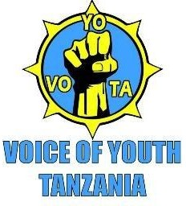

VOICE OF YOUTH TANZANIA (VOYOTA)

ANNUAL REPORT 2018

Table of Contents
Executive Summary 2
  - Introduction 4
  - Voice of Youth Tanzania (VOYOTA) Partnership 5
  - Voice of Youth Tanzania (VOYOTA) Volunteers and Experts. 5
  - Reproductive Health Program 5
  - Sauti ya Binti Project 5
  - Niambie ukweli Campegn 11
  - Life skills training 13
3.0 International Days 14
3.1. African child 14
  - World AIDS Day 15
  - Community Awareness Program for Preventing Violent Extremism in Tanzania 15
  - UN International Women's Day Commemoration 16
3WANENE schomedy tourol co 17
  - UN International Youth Day 17
  - Good Deeds Day 18
3. 8 Young leadership East African Summit 19
- 9 Tanzania national symposium 24
- 0 Media Engagement 25
4. 1 other Engagement 28
5.0 challenges… 29

EXECUTIVE SUMMARY

This is the first Strategic Plan that VOICE OF YOUTH -TANZANIA has developed since its establishment.
The formation of VOYOTA lay heavily on the ground that Tanzania youth have not had most of the issues affecting them properly addressed. VOYOTA continues to be a major stakeholder in the transformation of Tanzania through proliferation of young people’s voices.
The need for policy reforms further informs VOYOTA’s need to engage actively and be counted in the much desired change through dialogue, negotiations and offering alternative, but constructive solutions and policies.
VOYOTA has, since her establishment, set out to mobilize young people into income generating activities, economic empowerment and sexual and reproductive health rights advocacy and awareness and environmental conservation awareness among others. VOYOTA is currently actively engaged in Environmental conservation, sustainable development, and economic empowerment, entrepreneurship, and charity activities among others.
VOYOTA’s vision an informed and empowered youth population that own and champion socioeconomic development and uphold the ideals of social justice and gender equality with a mission to support youth efforts by promoting social welfare through research, vocational trainings, economic empowerment, awareness raising, networking and advocacy.
The theme of the plan is ““fostering solutions for the 21st century.” It has been clear from time immemorial that young people in different parts of the world played and still continue to play a significant role in the transformation of the world through innovations, creativity and critical thinking. It is on such grounds that VOYOTA’s Strategic Plan 2018/2023 is premised to create hope and inspire young people to not only be the change they want to see, but also offer positive and constructive alternative solutions to the problems of the 21st Century in Tanzania and the world at large.
Despite the young people in Tanzania being the majority of the total population, majority of them continue to be parasites to their parents, guardians and friends engaged in gainful activities. This kind of relationship not only makes young people to be potential criminals in the future, but also poses an economic hazard to Tanzanian’s economy. Unless significant interventions in enterprise and business have been undertaken by ministry of Youth and other stakeholders, there is bound to be a social disaster caused by the unemployed and financially less independent majority population. It is also on such grounds that we at VOYOTA believe that in order for youth to be active players and decision makers in the socio-economic, accountability and community engagement, they first have to be economically useful. This economic independence

not only gives them a firmer and stronger voice, but also most likely to influence key decisions even from outside.
On that ground therefore, VOYOTA shall establish programs that seeks to engage government and other development partners to institute policies, programs and strategies in addition to the existent ones towards the economic transformation of young people’s lives in Tanzania. In order for VOYOTA to fulfill its mandate, VOYOTA shall over the next five years undertake a series of interconnected interventions under the four program areas that we believe shall not only address the purpose for VOYOTA’s existence, but also create change and transformation in the next five years. These areas which form the strategic objectives of the plan include;
Programme area 1: Women Rights especially on Health education, Sexual Reproductive Health and Right, HIV/AIDS and Gender based Violence consultation.
Programme area 2: Governance, Advocacy, accountability and Leadership. Programarea area 3: Civic competence and community engagements
Programme area 4: Improvement and enhancement of improved grassroots livelihoods of. Programme area 5: Art and culture empowerment
Over the next five years therefore, VOYOTA shall implement interventions for youth development at the national, local and international levels and establish strategic partnerships in and outside the country so as to have a multi stakeholder force in the quest and attainment of the hence forth set goals and objectives.
In the first place, attainment of financial support for VOYOTA’s activities shall be very significant in setting the pace and enabling the achievement of the further set goal. In so doing, the support shall enable VOYOTA to advocate and equip student leaders within institutions of higher learning in Tanzania with skills in Evidence Based Advocacy so as to cause policy reforms by both government and institutions of higher learning. This shall go a long way in creating an environment that is not only friendly, but also encompassing in enabling students and parents to educate their children. Statistics show that out of many students who join tertiary institutions, majority of them drop out in the first years of in the third years and final to graduate. Additionally, the financing shall also help VOYOTA to enhance governance, participatory democracy, Advocacy and accountability at the lower local councils where youth leaders shall be equipped and mentored with knowledge and skills on budget process and monitoring and implementation. This shall improve service provision and tax justice. VOYOTA shall also implement programs that are geared towards enhancing the civic competence and community engagement of female youth. several researches continue to reveal that whereas several affirmative action programs have been put in place by the government, the participation of female youth and women in general and community and decision-making process is limited

largely due to the societal and cultural barriers, VOYOTA shall therefore go a long way in putting in place mechanisms for creating societies that embrace the need for women involvement in civic processes.
Lastly, but not least, VOYOTA shall establish programmes geared towards improvement and enhancement of improved grassroots livelihoods of youth. This shall involve a series of interconnected processes where VOYOTA shall agitate for increased funding by the government towards critical youth concerns and activities to enable young people to transform their economic lives. We believe that empowering young men and women only through civic competence, accountability and governance may not be enough to enable young people reach their full positive and mental prowess and hence the need for programmes that emancipate them financially and economically.

INTRODUCTION
This report covers institutional development and all organization project activities implemented in 2018. This includes the three (3) thematic areas that VOYOTA operates including Health, Economic empowerment and Civic Engagement.
Voice of Youth Tanzania in 2018 partnered with different organizations through the following events; UN International Women Day commemoration with EAC partnership, Youth Engagement on Media, Agriculture exhibition prepared by Jukwaa la Wakulima Meru (JUWAME) in collaboration with VOYOTA, Kisa Girls, Viumbe vamizi at community church, young leadership east African summit (Youlead) Youth campaign, life skills training, good deeds day in collaboration with Usa River police station, Women Match Day, proposal writing, Her-Voice fund project based in Gender Based Violence, peer education, youth Dialogue at palace Hotel, edu-entertainment, full participation in preparation and conducting National youth symposiums in Tanzania, the East African youth legislation and annual meeting of all civil societies and organization in Tanzania that held at the Parliament of Tanzania.
VOYOTA also continues to learn different new ideas which increase the capacity of staffs and organization brand. That includes the media engagements, capacity building and development among the team member of the organization. These increased experience opens doors for more projects and other resources.

VOYOTA PARTINERS.
Voice of Youth Tanzania is non-government organization, non-partisan but this fact does not mean has not participating with these organizations. VOYOTA is full and partial participating with both Government and other non-government organization which includes Vision for Youth, WANENE Entertainment, MWOSE -TANZANIA, Her-Voice fund, JUWAME, both horizontal and vertical.

VOICE OF YOUTH TANZANIA (VOYOTA) VOLUNTEERS AND EXPERTS.

VOYOTA has expertise that are volunteering in working which includes 1 from Uganda, 1 from Kenya and other 12 expert volunteering around the country in two zones that is Dar es salaam and Arusha.

SEXUAL REPRODUCTIVE HEALTH AND RIGHTS PROJECT

In this sexual reproductive health and rights project, VOYOTA has been implemented several project and activities that is , Kisa Girls, African Child Day, Niambie ukweli usinifiche youth campaingn, SAUTI YA BINTI PROJECT on Gender Based Violation and HIV/AIDS that supported by Her-Voice Fund.
  - SAUTI YA BINTI PROJECT

BACKGROUND INFORMATION ON THE PROJECT:
Sauti Ya Binti project aims at putting female student leaders at the forefront of fighting against gender based violence, creating opportunities and platforms where they can air their views and also enhance their leadership capacities so as to create a safe learning environment for all and prepare them for life after schools. The project employs aphased approach. The first phase of the project focused on consultations with female students leaders from secondary schools in Tanzania on GBV. The second phase of the project is ongoing where those that participate in the consultations are forming young leaders’ forums in schools. The third phase which is very important again will focus on equipping them with skills and exposing them to many opportunities.
The first phase of the project was supported by HERVOICEFUND. In the first phase, Three consultative forums were conducted in the three locations of Arusha namely Arumeru, Arusha municipality and Arusha district where female student leaders from select secondary schools were invited to present their views on gender based violence with core focus on teacher -student sexual harassment of girls in schools and how to protect adolescent girls from gender based violence in schools among others. These forums culminated into the formulation of a regional network of female student leaders on sexual based violence and HIV/ AIDS. Through the networks, the female student leaders will continue to access mentoring, trainings and resources on SRHR, HIV/AIDS, leadership, gender based violence among others so that they can create awareness in their schools, homes and or the wider communities of origin or residence under the leadership of one female student leader elected by the rest and in close liaison with VOYOTA.
A national consultative, accountability awareness forum where select girls from the consultations in Arusha forums were invited to present their views from the regional findings to various duty bearers and stakeholders including representatives from the ministry of health, ministry of education and parliament among others to interfaceand to raise their views, press for accountability and lobby for a framework on sexual based violence prevention in schools.
Additionally, a radio talk show was held on radio 5 FM in Arushathat discussed on sexual harassment of adolescent girls in schools by teachers, none teaching staff and male student counterparts. It is expected that by the end of the activities, the government will have committed to enactment of a national policy onprotection of adolescent girls from sexual harassment and prevention of spread of HIV/ IADS by staff and male student/Pupil counterparts.

PROJECT OBJECTIVES:

below were objectives of the project prior to inception.

    - To create a platform where female student leaders in secondary schools in Tanzania can air out their views on sexual and reproductive health rights, sexual based violence in schools and advocate for formulation of a national legal framework on prevention and protection of adolescent girls from sexual harassment by teachers, fellow male students among others.
    - To put adolescent girls at the forefront of creating awareness about HIV/ AIDs spread in schools and effect of sexual based harassment on female adolescent academic performance among others
    - To empower adolescent girls to advocate for implementation and compliance of laws that prohibit sexual harassment, teenage pregnancy and early marriage of young girls and women
PLANNED ACTIVITIES:

NO | ACTIVITY | STATUS
1 | Three consultative events conducted in the three locations of Arusha namely Arumeru, Arusha municipality and Arusha district where female student leaders from select secondary schools were invited to present their views on GIRLS sexual harassment by teachers, and the society in schools and how to protect adolescent girls from gender based violence in  schools among others. | Done
2 | A national consultative, accountability awareness forum where select girls from the consultations in Arusha forums shall be invited to present their views from the regional findings interface to raise their views, present accountability and lobby for a framework on  sexual based violence prevention in schools | Done
3 | Hold two talk shows one on radio and the other on television on sexual harassment of  adolescent girls in schools by teachers, none teaching staff and male student counterparts | One radio talk  show done

SUCCESSFUL INTERVENTIONS AND DELIVERABLES

NO | INTERVENTION | DESCRIPTIVE NARRATIVE
1 | Three district based consultative forums in Arusha region involving female student leaders, teachers and VOYOTA held. | The forums were conducted in three locations of Arusha Region in Arumeru District at Unambwe secondary school, Arusha Municipal at Vision for Youth office and Arusha District at S.O.S village Main office. Female student leaders from selected secondary schools were invited to present their views on teacher sexual harassment of girls in schools and how to protect adolescent girls from gender based violence in schools among others.The forums involved focused group discussions, plenary discussion, presentations and facilitation. The findings from the three consultative forums were used to develop a draft memorandum from the female student leaders that was presented at the National conference to inform the  formation of a national policy on how to tackle gender based violence in schools and sexual reproductive health.
2 | Alternative spaces for girls’ engagement and advocacy on gender based violence and sexual reproductive health and rights formed. They include: Girls clubs in select schools, Arusha regional network of female student leaders and National platform called Tanzania female student leaders network on gender based violence and female reproductive health and rights. Linkages and networking between select schools to regional network and  National networks. | Key outputs of the forums was the creation of alternative spaces for female students to advocate for a gender based violence free learning environment and sexual reproductive health and rights. Some of the spaces included creation of district based networks, school clubs and a national platform where female student leaders can advocate and lobby on sexual based violence and HIV/ AIDS. Through the networks formulated, the female student leaders will continue to access mentoring, trainings and resources on SRHR, HIV/AIDS, leadership, Gender Based Violence so that they can create awareness in their schools, homes and the wider communities of origin or residence. This networks also form a formal structure of engagement between the students and VOYOTA.

3 | One radio talk show at 5 FM on sexual harassment of adolescent girls in schools by teachers, none teaching staff and male student counterparts  was successfully held.also we had one tv show held at mlimani tv | There was a 30 minutes talk show on radio 5 FM from 12 pm to 12:30 pm (prime time) that discussed sexual harassment of adolescent girls in schools by teachers, none teaching staff and male student counterparts was successfully held. The show was graced  by VOYOTA’s programme coordinator. It involved questions and answers and an interactive call in session from listeners.
4 | Female student leaders memorandum on gender based violence and female reproductive health and rights has been developed | All views from female student forums at district level have been consolidated into a memorandum that was presented to stakeholders at the national consultative, accountability awareness forum on gender based violence and sexual reproductive health and rights for  teenage girls in school.
5 | One National consultative forum on gender based violence and sexual reproductive health and rights. | A national consultative forum was organized in Dar es Salaam that brought together 15 stakeholders form the following select groups: The following groups of resource persons are targeted: representatives of school girls, ministry of education science and technology, ministry of health, community development, gender, elderly and children, student union representatives, representative from Parliament, teacher Union, media that include (East African Television, Millard Ayo) Other stake holders from non-state actors that included (Action Aid, UNFPA,WASH, and VSO Tanzania) with members/representatives from VOYOTA.  The event aspired to achieve the following objectives:  To create awareness on GBV and sexual reproductive health and rights in secondary schools at the National level.  To lobby duty bearers to support accountability mechanisms on GBV sexual reproductive health and rights and in secondary schools  To create a national platform on advocacy on GBV sexual reproductive health and rights in secondary schools in Tanzania The conference is to be a one day meeting that will bring together stakeholders from the ministries of education and health, community development, gender, elderly and children, student union (TSNP), parliament, teachers union (CWT) and student representatives from Arusha region.  The conference was conducted through open plenary discussions, plenary presentations, focused group discussions, varying facilitations and memorandum presentations.  There were also live twits, blogging and social media engagement pre, during and post the conference.  The following outcomes were realized:  A national platform/network for girls in school where gender based violence and Sexual reproductive health and rights (SRHR) issues are advocated  Development of a draft framework on sexual reproductive health and gender based violence in schools in Tanzania  Development of a national communique on gender based violence and sexual reproductive health in secondary school Tanzania

6 | Draft compact on GBV to guide | VOYOTA has developed a draft policy guidelines on how to tackle
 | policyformulation to tackle gender | gender based violence and female sexual reproductive health and
 | based violence in schools developed. | rights in schools. This document shall be presented to a
 |  | representative from parliament to petition formation of legislation
 |  | to tackle gender based violence in learning environments in
 |  | Tanzania and sexual reproductive health and rights.

PROJECT OUTPUT/ COMES

QUANTITATIVE OUTCOMES | The program has directly reached 80 persons segregated as below:  Arumeru district at Unambwe secondary school.  Five schools at Arumeru District attended the consultation. The schools includes Unambwe secondary school, Mariado secondary school, Muungano secondary school, Uraki secondary school and Goodwill secondary school.  Unambwe secondary was represented by seven (7) female student leaders with one (1) Teacher.  Mariado secondary was represented by four (4) female student leaders with one (1) teacher. Uraki secondary was represented by three (3) female student leaders.  Muungano secondary school was represented by three female student leaders with one (1) teacher  Goodwill secondary school was represented by three student leaders with one (1) teacher. VOYOTA was represented by five members. There was one friend of VOYOTA from Kenya and one consultant.  This consultation reached a total of 31 participants.  In Arusha Municipal  21 female student leaders attended the consultation from 10 schools segregated as follows: Ngarenaro secondary school (2),  Losirway secondary school (2), Sakina secondary school (2), Kaloleni secondary school (2), Elerai secondary school (4), Bishop Daniel (3),  Olmoti secondary school (2), Moshono secondary school (2), Kiranyi secondary school (1), Sorenyi secondary school (1),  - representatives from one partner organizations of VOYOTA Vision for Youth.  - Teachers, 1 reporter from ABC radio and television and 4 VOYOTA consultants.  Therefore, this consultation consisted of 31 participants.  In Arusha District,  18 female student leaders from S.O.S secondary school, Rockland and S.O.S Primary school  were directly reached, 1 representatives from SOS village of Arusha, one (1) facilitators, 2 teacher Rock Land SOS secondary schools respectively and I representative from Youth and

Child inter-developing program Tanzania (YACIP-Tanzania) and three (3) VOYOTA support team.
This event reached 26 individuals directly.
Also, five guiding tools have been formed as a result of this project so far. They are:
One student memorandum has been developed that was presented at the National conference in Dar es salaam, guidelines document has been developed to support formation, activation and operationalization of girls clubs in Arusha region as a guide. An article has also been so far developed describing the processes that the forums employed as a case study or a capacity development reference point that featured prominently on social media. There was also a terms of reference that was developed as a process guideline for the National conference. A draft policy document on GBV and sexual reproductive health rights in schools in Tanzania has been
developed.
QUALITATIVE OUTCOMES | It is difficult to note credible qualitative outcomes of the project at this stage in terms of changes in attitudes, behaviour and character. However, there are few indicators that direct to initial shift in attitudes, behaviour and character of the primary targets( girls) and teachers at this stage that we can attribute to the interventions of the project that have already been developed. This include:  - The willingness to establish a successful Network of girls through regular school Forums in Connection to Youth Leaders from each School, active participation in forums, operationalization and activation of those platforms and networking and creating linkages with Government, other non-state actors, Organization and VOYOTA.  - The ability of the girls to develop a memorandum that was consolidated by VOYOTA that was eventually presented during the National conference in Dar es Salaam points to a shift in attitudes, ability and character of self-confidence and awareness.  - The willingness of parents in releasing their children, the willingness of schools in releasing their students and the willingness of other select stakeholders in attending to and actively participating in the forums is an indicator of a society that is embracing efforts in cubing gender based violence and the accompanying advocacy on sexual reproductive health and rights among teenage girls in Tanzania especially in Arusha region.  - The willingness of National stakeholders to take up the draft policy on gender based violence in schools and sexual reproductive health rights for onward advocacy initiatives with relevant key decision makers like parliament is also an indicator that  attitudes are strategically shifting towards combating GBV in schools.

Key learnings and recommendations:

KEY LEARNINGS | CONTEXT | RECOMMENDATION
The following key learning areas in HIV/AIDs were tackled: Introduction HIV/AIDs, definition of terms, initial management of rape and defilement, treatment around the CD4, statistics on infections, effects of HIV to girls in schools, relationship between  HIV/AIDs and GBV, manifestation of HIV/AIDs and | Both HIV/AIDS and gender based violence have more or less the same context. The following context was developed.  Low levels of capacity in tackling gender based violence and HIV/AID’s.  Lack of structured  communication channels where girls can air their | The following key recommendations were developed:  Safe-Houses for Girls.  Accountability from Grassroots (Home grounds) to national levels.  Sustained capacity Building to Adolescent in schools and within the Community.

its effect in learning  environments. | views, cultural and religious biasness and stereotypes, lack of alternative spaces of girls engagement like girls clubs in schools, inadequate mentors and trusted support system for victims of GBV and HIV/AIDs in schools, lack of safer houses for victims of GBV rehabilitation processes in schools, insufficient budgetary allocations to advocate and create awareness in schools, stigma associated with GBV and HIV victims in the society is hampering efforts to tackle it and poor enforcement of regulations in schools.
Gender Based Violence(GVB) Across all the forums, an in- depth understanding of GBV was done beginning with expectation setting, definition of GBV, forms of GBV, types of GBV, manifestations of GBV, effects of GBV in a learning environment, relationship between GBV and HIV/AIDs in schools, probable ways of confronting GBV and recommendations and way forward.  The forums were facilitated through direct plenary sessions, questions and answer sessions, focused group discussions and plenary presentations. |  | Some of the key recommendations included: Accountability from Grassroots (Home grounds) to national levels.  Capacity Building to Adolescent in schools and within the Community  The Community to be responsible for GVB by immediately reporting the Occurrence of any Gender Based Violence to the appropriate agent/authority.  Students should follow the By-Laws made by respective schools or institutes.  There should regular Meeting between School management and students which provide a fair freedom of Expression to those misconducts/violence than conducting in a school setting.  The Government should enact and enforce Laws, rules, regulation and policies to the respective Community against such Violence.  VOYOTA, Government and Other Institutes/authorities should have Progressive Support to Forums, Research and Workshops in order to reach more Population of Tanzania  Community.

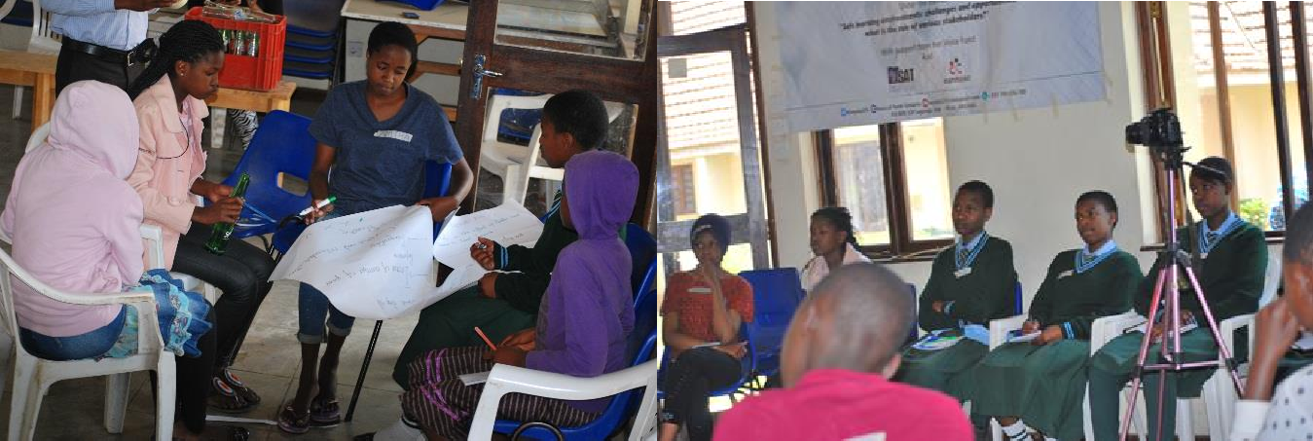
01st October 2018 at S.O.S Village main office Hall Arusha District adolescence girls discussing what challenges facing with assertive recommendations to solve Gender Based Violence at the school level.

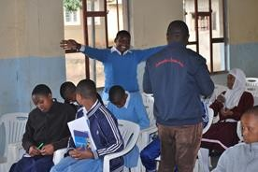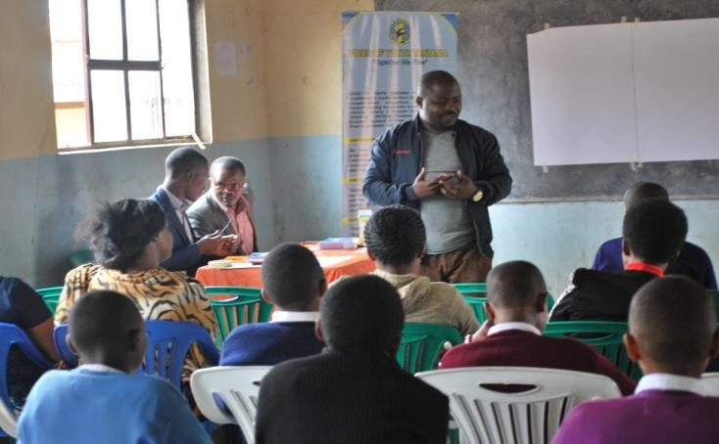

28th September 2018 at Unambwe secondary school, student from Meru district expressing their ideas and and their needs to government and VOYOTA and VOYOTA facilitator is advocating before them.
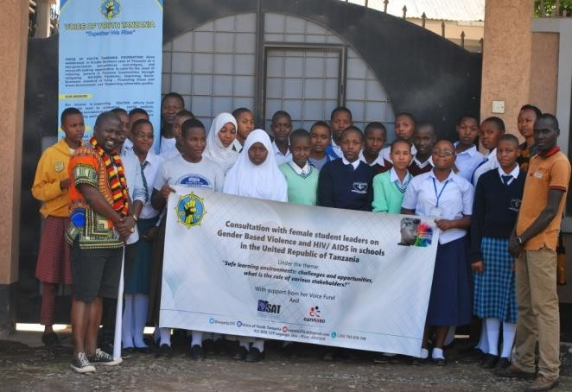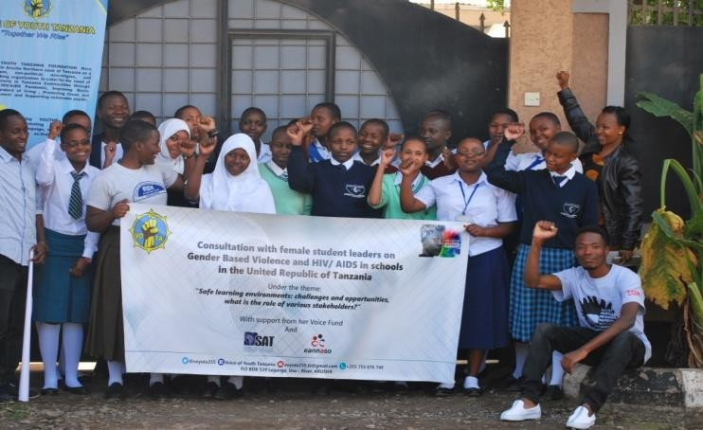

29th September 2018 whereby the consultation with female students leaders of secondary schools on Gender Based Violence at Arusha Manicipal.
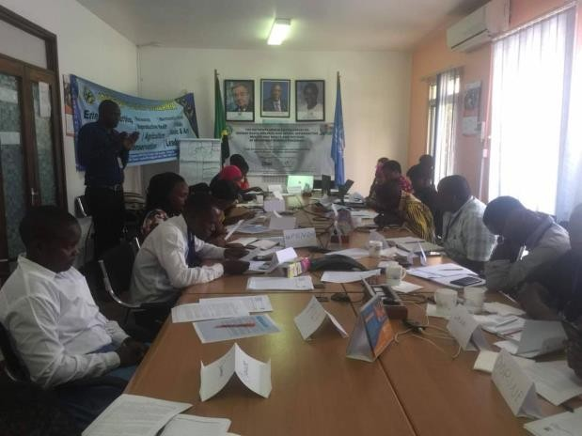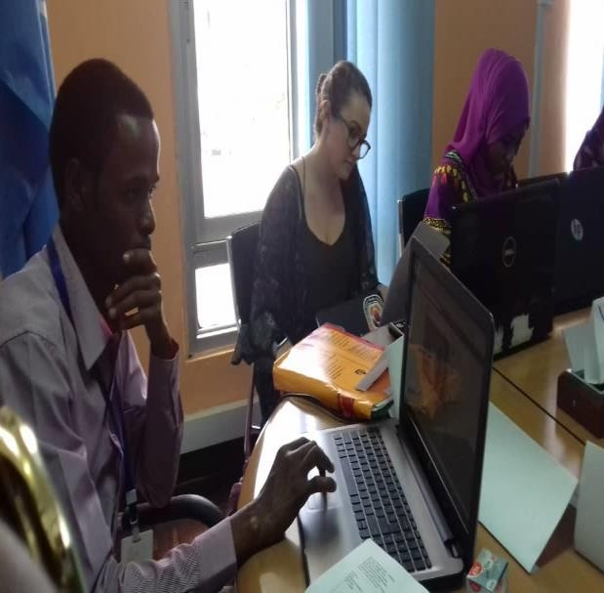

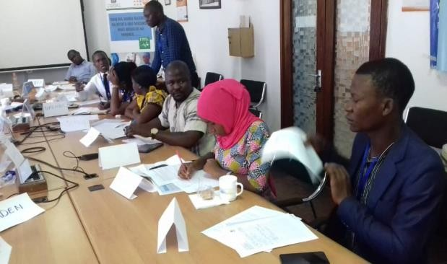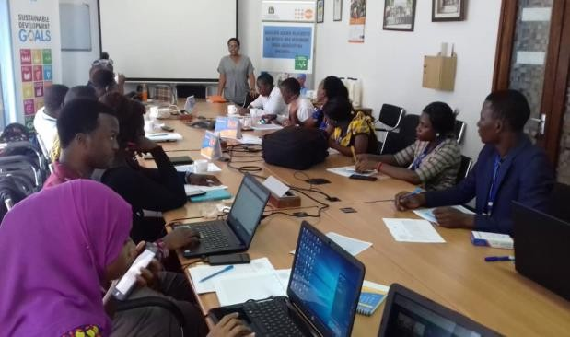

19th October 2018 at the National consultation forum on GBV, SRHR and HIV/AIDS in secondary schools of Tanzania whereby stakeholders were both Governmental officials, NGOs and student representatives

NIAMBIE UKWELI USINIFICHE YOUTH CAMPAINGN.

This is campaign activity of which involved governmental officials that is gender desk, Regional clinical Doctor, public officer in legal investigation basical in illicit and drugs abuse, District Administration secretary, that aimed to reach youth at the school level whereby 800 students and 14 teachers of Engutoto secondary school at Monduli District in Arusha Region were the benefit of this campaign. In corroborations with those desks mentioned here above, HIV/AIDS and other transmitted disease and its effect to youth and community at large, how to prevent from the use of drug abuse, youth awareness, were the subject that taught and two witnesses from rehabilation of drugs and drug abuse from kisongo soba house they presented how drug abuse caused bad effect in their life history. In this campaign the focused group were the youth, and the key leaning is the awareness, transmission diseases, drug abuse and its impact to the youth.
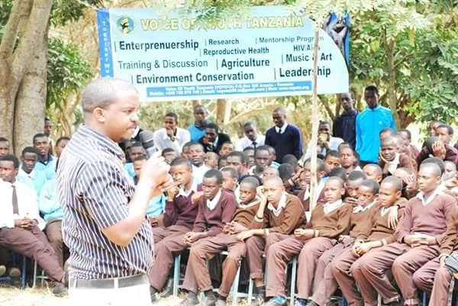
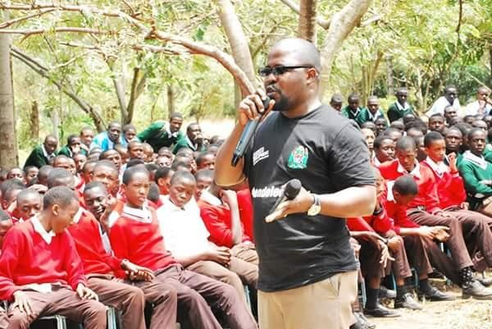
Arusha Reginal Doctor (left) and VOYOTA Director training youth at Engutoto secondary school.

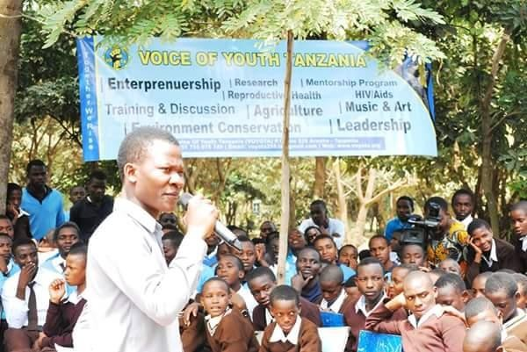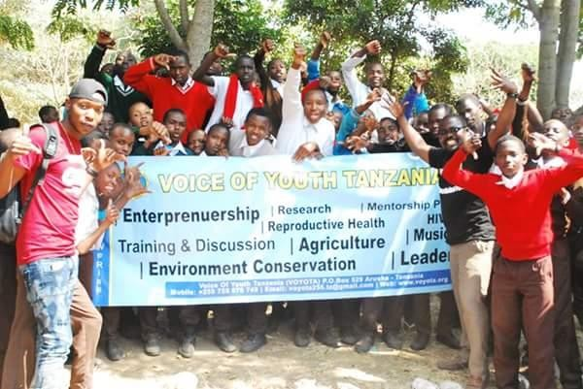

Awareness training to Youth by VOYOTA coordinator Musa Paul at Engutoto secondary school.

3 LIFE SKILLS TRAINING.

Life skills are abilities for adaptive and positive behavior that enable humans to deal effectively with the demands and challenges of life. This concept is also termed as psychosocial competency. The subject varies greatly depending on social norms and community expectations but skills that function for well-being and aid individuals to develop into active and productive members of their communities are considered as life skills. In a constantly changing environment, having life skills is an essential part of being able to meet the challenges of everyday life. The dramatic changes in global economies over the past five years have been matched with the transformation in technology and these are all impacting on education, the workplace and our home life. To cope with the increasing pace and change of modern life, students need new life skills such as the ability to deal with stress and frustration. Today’s students will have many new jobs over the course of their lives, with associated pressures and the need for flexibility. VOYOTA have been training the youth at two (2) out of five schools which are Uraki, Unambwe and 1000 students were trained. At this training, the training has two kinds of benefit which are both benefit from the individuals and Benefits for society

Benefits for the individual
In everyday life, the development of life skills helps students to:

  - Find new ways of thinking and problem solving.

  - Recognize the impact of their actions and teaches them to take responsibility for what they do rather than blame others.
  - Build confidence both in spoken skills and for group collaboration and cooperation
  - Analyze options, make decisions and understand why they make certain choices outside the classroom.
  - Develop a greater sense of self-awareness and appreciation for others

The more we develop life skills individually, the more these affect and benefit the world in which we live in:

Benefits for society.

  - Recognizing cultural awareness and citizenship makes international cooperation easier
  - Respecting diversity allows creativity and imagination to flourish developing a more tolerant society
  - Developing negotiation skills, the ability to network and empathies can help to build resolutions rather than resentments.

INTERNATIONAL DAYS.

  - THE AFRICAN CHILD DAY.

African Child Day is an event which usually carried out every year. Started many years ago with the aim of remembering the torture and other mental and physical abuse faced South African children.
BACKGROUND INFORMATION ON THE ACTIVITY:

The main activity was a meeting which deliberately aimed at discussing all important matter on the preparations of the African Day Celebrations. Different NGOs including VOYOTA were invited to participate in giving out their views, contribute to the budget together with taking role to play so as to facilitate the Event. At the events 50 stakeholders were invited and t hey full participated and here VOYOTA has been participated in the preparation of the event that held at June 2018.

ACTIVITY OBJECTIVES OF THE EVENT.
In this activity there are 3 key leanings which are;

    - To plan on how to facilitate the African Child Day to be successful
    - Fundraising to get money for covering a budget set.
    - To get human resources who can carry out activities before and during the event.

Up on this key leaning activities Participants gave out their constructive views and opinions on how to make an event successful. Government officials and representatives from different NGOs pledged amounts which was enough to cover the budget. Every stakeholder selected an activity to perform so as to assist the event become successful.

WORLD AIDS DAY

World AIDS Day originated at the 1988 World Summit of Ministers of Health on Programmes for AIDS Prevention. Since then, every year United Nations agencies, governments and civil society join together to campaign around specific themes related to AIDS. World AIDS Day 2018 theme encourages everyone to know their HIV status. As of this year voice of youth Tanzania was invited by heal international in lighting up candles for the deceased and bringing awareness to the community. The event started this year and it is to be made a routine in the next coming years as
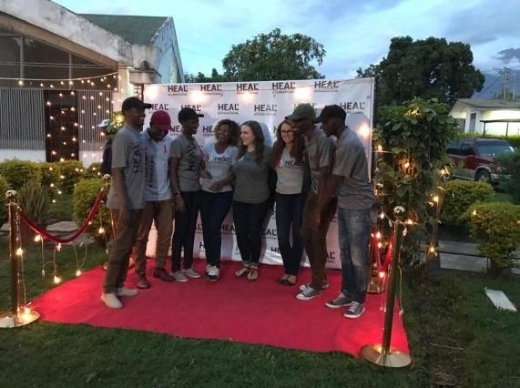
per heal international country director

World AIDS Day takes place on the 1st December each year. It’s an opportunity for people worldwide to unite in the fight against HIV, to show support for people living with HIV, and to commemorate those who have died from an AIDS-related illness. It was founded in 1988, whereby world AIDS Day was the first ever global health day. We as voice of youth Tanzania collaborated with heal international in lighting up candles for the deceased who passed away due to the
disease as well as raising awareness and
1st November 2018 World Aids Day at Arusha Declaration Museum whereby VOYOTA TEAM participated full with The Heal International Organization.
fight for an HIV free generation by insisting them to get tested under a Swahili slogan “ pima, jitambue, ishi” meaning get tested, be aware of yourself and finally get to live. At this events that aimed To bring the community together and allow them to honor those who have lost their lives to the disease and To raise awareness and fight for an HIV free generation where by more than 50 people attended.

Community Awareness Program for Preventing Violent Extremism (PVE) in Tanzania (CAPPTAN)
VOICE OF YOUTH TANZANIA have been participated in the training that prepared by Vision for youth with inherit your Rights in the training of Human Rights and preventing violent Extremism in Tanzania The project aims to Prevent Violent Extremism by capacitating local organization in different topics associated with Violent Extremism. The following topics were covered, Introduction of Violent Extremism within the context of Tanzania, Youth radicalization, Marginalized groups, Gender, extreme Violence, the reasons for extremist groups and Human rights trained by Inherit your Rights. The project was implemented in Arusha, at JR Institution VOYOTA intends to incorporate this aspect in its civic education programs by educating more people.
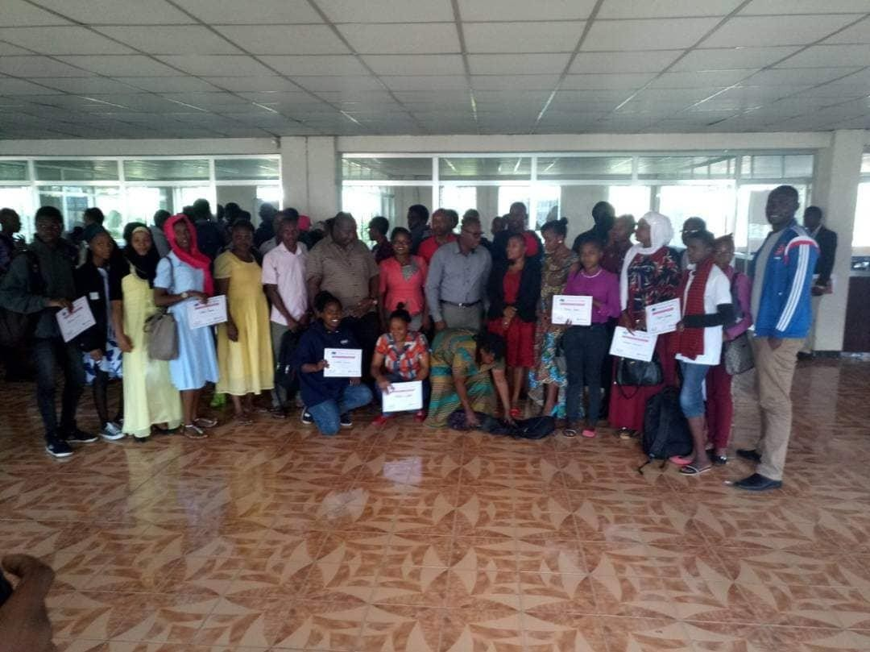
participants who involved in Community Awareness Program for Preventing Violent Extremism (PVE) in Tanzania (CAPPTAN) at JR institution at Arusha hosted by V4Y and Inherit Your Rights whereby member were awarded certificate of participation.

UN International Women’s Day Commemoration
Voice of youth Tanzania in collaboration with other stakeholders, Arusha City Council, Arusha District and EAC Secretariat commemorate UN International Women’s Day on March 8th 2018 with a theme “press for progress’’.VOYOTA with due respects of other stakeholders, participated in celebrated acts of courages and derermination of women who have plyed an extraordinary role in the history of womens emancipation through testmonies, donated medical equipment to the department of maternal and cleaning the market.

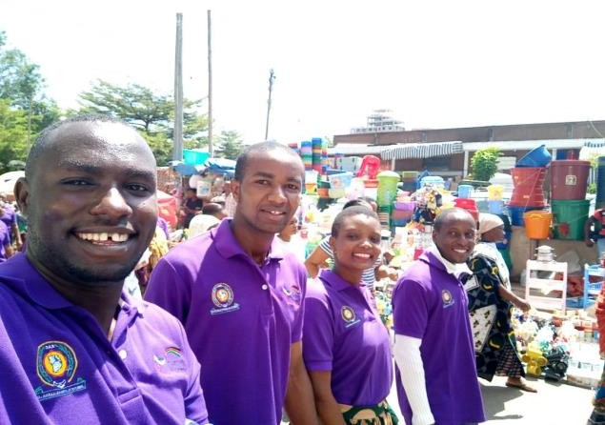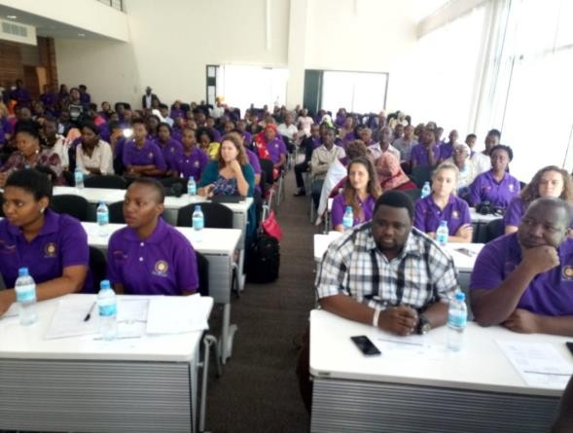
8th March 2018 people with due respects to VOYOTA participating this women’s day of commemoration.
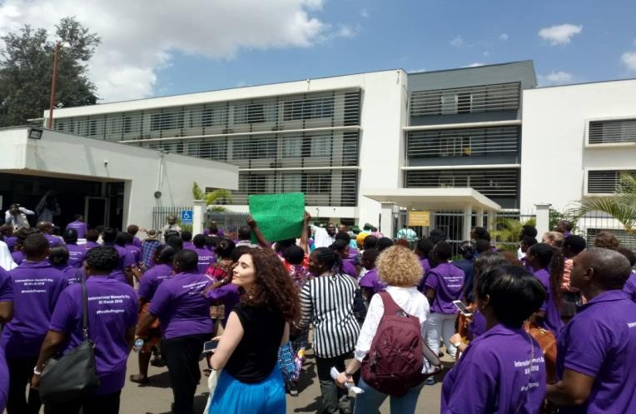
at hospital where they donated medical equipment on the united nation women’s day commemoration 3rd march 2018

WANENE SCHOOL COMEDY TOUR.

In November 22nd, 2018 at PEACE LAND SECONDARY SCHOOL – KIMARA SUKA Dar es salaam, VOYOTA in collaboration with WANENE Entertainments Educating Students about awereness and Early pregnancies, its effect and how to take action against Early pregnancy whereby 10 Members from Wanene Entertainment Team, 3 Members from VOYOTA , 300 Students from Peace Land Secondary School and 6 Teachers of the School Peace Land Secondary School, The theme deliverables were respectively presented to the targeted groups as planned in form of Comedy Show (Wanene Entertainment) and Lecturing (VOYOTA.

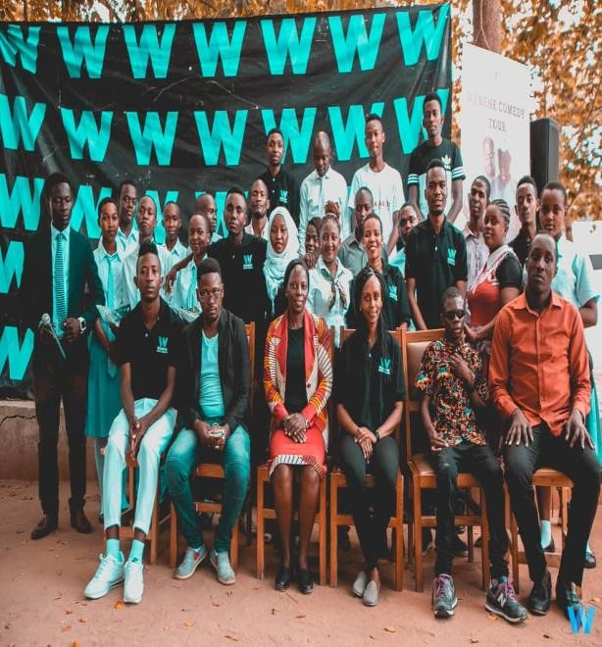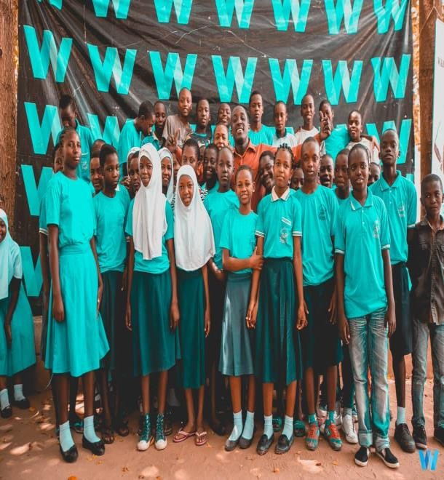
November 22nd, 2018 at peace land secondary school – kimara suka Dar es salaam VOYOTA, WANENE entertainment, teachers and students after the training and capacity building.
  - UN International Youth Day Commemoration at Patandi Teachers College of Arusha. This is the international activity that used to conduct every year on 12th August. In 2018The United Nation youth day was celebrated at Arusha Tanzania at Patandi Teachers College whereby the Guest of Honor was The Deputy Minister for state in prime minister’s office responsible for policy, parliament affairs, labor, employment, youth, and the disabled people whereby the theme for this year was “Safe Space For Youth‟. Voice of Youth Tanzania partnered with Regional Commissioner’s Office under Regional Youth Development officer and other stakeholders to celebrate UN International Youth day. At this day, VOYOTA was among of event organizer and full participated from the preparation up at a closing moment.
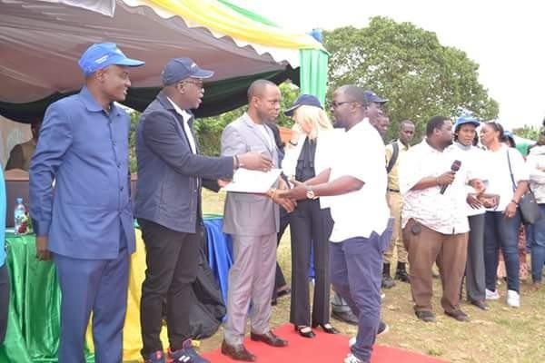

On behalf of VOYOTA, Vincent uhega Director speaking and receiving certificate of appreciation before the Guest of Honor Deputy Minister in Prime Minister’s office responsible for responsible for policy, parliament affairs, labor, employment, youth, and the disabled people, who stands between Arusha Reginal commissioner Mrisho Gambo(1ST from Left) and Meru District Commisioner Jerry Muro

(3rd from left).12th August 2018.

GOOD DEEDS DAY.
This is the global day that people from 100 countries used to do good deeds for the benefits of others and the planet. At this year Voice Of Youth Tanzani a joined this movement by involving different stakeholders and youth volunteers by planting trees at USA RIVER Police Station of Arusha. That conducted on 18th April 2018. Other stakeholders includes Vision For Youth (V4Y), Youth from SOS village, Youth from Tumaini university Makumira, youth from the institute of Community Development Tengerru (TIC D) Police from USA RIVER POLICE STATION. And other volunteers.
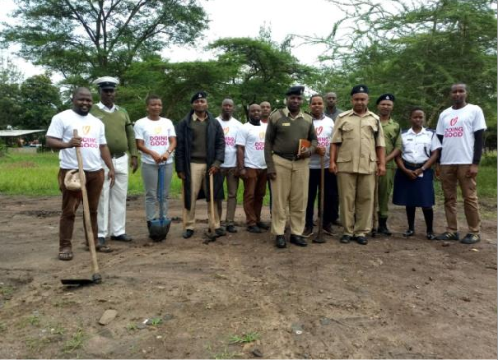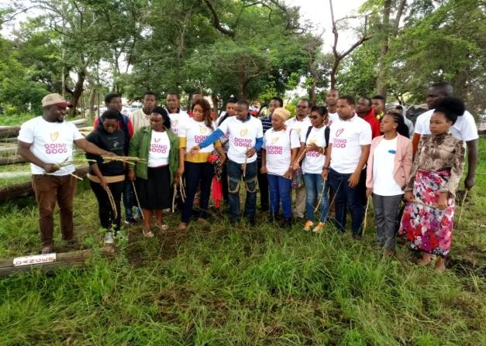
VVI I

VOYOTA, Police officers, V4Y, University student and other volunteers participating in painting trees at Usa River police station in Good Deeds Day, 18th April 2018
NN

YOUNG LEADERSHIP EAST AFRICAN SUMMIT (Youlead).

INTRODUCTION:

Youlead is a unique opportunity for youth leaders to gather for training and facilitating cross country youth networking to accelerate the EAC regional integration aspirations. As the name suggests YouLead is derived from the word Youth leadership it’s all about young leaders coming together to learn and explore ways to help grow, support and participate in youth leadership and mission. We as Voice of Youth Tanzania (VOYOTA) got a chance to fully participate in the summit by both volunteering and participating.

BACKGROUND INFORMATION ON THE ACTIVITY:

Youlead was organised since 2017 by MS-Training Centre for Development Cooperation, the East African Community (EAC) Political Affairs Department and Africa Alliance of YMCAs with the participation of other partners, the East Africa Youth Leadership Summit (YouLead) is East Africa’s biggest youth gathering recognised by the EAC in line with the provisions of the EAC Youth Policy

(2016) priority 14 which mandates the EAC Secretariat to build networks and partnerships to, ‘Institute an Annual Youth Leaders’ Forum with the EAC Secretary General as a regional platform for youth engagement with the EAC leadership.

YouLead gives and amplifies youth voices in key regional political processes and strengthens their mandate to participate in leadership at country level. YouLead facilitates cross-country youth networking to accelerate the EAC regional integration aspirations. Participants are mobilized across various sectors: political leaders and policy makers, business, ICT, agriculture and the non-
governmental organizations.

Activity OBJECTIVES:

- To increase the quality and number of youth leaders holding political positions across EAC.
- To deepen business cooperation and partnership among business leaders across EAC.
- To give youths a voice in key regional political processes of EAC and accelerating regional integration. Subject to these objectives it has also the following activities which are:
- -Discussions about National Youth Trends in Political & Economic Inclusion: Key asks for effective Youth Participation in EAC Integration Priorities and Processes.
- Discussions were done on Youth and SDGs: Framework for National & Regional Participation
- -Discussions were done on Youth in Trade, Enterprise and Employment: Regional Opportunities &Obstacles
- -Discussions were done on the EAC Youth Want: Youth Scenarios for Sustainable Regional Integration.
- There was a launch of an EAC mobile application. It’s now available on Google play/ app store. It’s a youth developed by the youth for the youth. It’s a platform that shows internships, jobs and scholarships.
SUCCESSFUL INTERVATION AND DELIVERABLES.

NO | INTERVENTION | DESCRITIVE NARRATIVE
1. | The EAC youth leaders were fully involved in the whole process of the program and it was conducted in several ways such as making plenary sessions,  stories from young leaders and delegates workshops. | Under several topics and agendas prepared by the organizers of the summit, all the EAC youths were involved fully in the discussions and they were given chances to air out their views in groups as well as individually.

SUCCESSFUL OUT COMES.

QUANTITATIVE OUTCOMES | - More than 150 young leaders of EAC have gained and exchanged new ideas and designed new initiatives for EAC integration.  - Nearly 50% Gender parity achievement among delegates  - No EAC country left behind - all 6 EAC countries represented
QUALITATIVE OUTCOMES | - Successful in helping youth understand their leadership role  - Successful in giving youth leaders an opportunity to meet and connect with fellow young leaders from across the  EAC.

KEY LEANING AND RECOMANDATIONS.

KEY LEARNINGS | CONTEXT | RECOMANDATIONS
National Youth Trends in Political & Economic Inclusion: Key asks for effective Youth Participation in EAC Integration Priorities and Processes | Here, every representative within the EAC had a chance to present what they discussed in their specific countries on how effective are youths in politics and economical activities and to what level are they included. | - Youths should cooperate in bringing development  - Youths should look for opportunities in the  EAC website.
 | Some of the recommendations made by several representatives of each country in the EAC includes ;  -There should be policies that support acceleration of economic and development issues.  -There should be a regional wise man power survey to compact the gaps because we are working more under assumptions.  - There should be a need to inform regional market to form a better intergration. | - Proper use of the social media.  - Be active to criticize politicians.  - Elections play a great part in the transformation of the society.  - Youth need to invest their time in development.
Youth and SDGs: Framework for National & Regional Participation | What UN is doing with regard to SDG 17 as far as young people are concerned is that; | - Youths need to move from Policy to Action.  - Youths should stop

 | UN has numerous of ways of involving youth. There are regional and country platforms. Example; In Rwanda, Youth Connect.  -Tanzania, there is Youth for African and SDG  How is it possible to end SDG no. 2 (zero hunger) within 12 years?  UN and governments will do their best to decrease to a level that is a significant level. Don’t always blame on the UN it’s a work of everyone. United Nations is to foster the environment that is sustainable. At the policy level, the UN makes sure the policies are good and sustainable too. ( Natalie Boucly, Country Director UNDP Tanzania) | blaming and adopt Action.  - Youths need to grab opportunities.  - Let’s take the 17 global goals as 17 global challenges.  - States will not achieve any of our global goals if youth are not involved.  - Youth are not separable from the global goals.  - Every youth need to question of how they can make contributions in their societies.
Youth in Trade, Enterprise and Employment: Regional Opportunities &Obstacles | -How can we foster youth employment through enterprise creation?  We should definitely avoid copy and paste. Youth need to be innovative.  - The recipes of success are Having faith, Doing things because change needs to be done. You won’t know what to start/how to start if you haven’t started it yet.  The tips of growing a business fast are;  -Technology, Proper use of | - Look what drives you passionately.  - Have best skills.  - Start from where you’re  - Positive mind.  - Tenacity.  - Be a stubborn optimist  - Be willing to change.  - Understand your value in relationships.

technology. Be updated on the basic technology information. Start with what you have.
-Start with an independent mind.
The EAC Youth Want: Youth Scenarios for Sustainable Regional Integration | -What can we do to make the change happen? We need to  focus on Advocacy, | -There is need of change of narratives. Leadership is  diverse; it doesn’t have to be on
 | Empowerment, Raising | the political space.
 | awareness and Create more
 | spaces.
 | -The benefits of having women and persons with disabilities in the integration is that | -Protocols are present, so youth need to lobby the allocation of these taxes.
 | - They are so innovative; hence their ideas will
 | contribute to the
 | growth of economy of a
 | state.
 | - Gives them a better attitude that they are
 | also included as part of
 | the community.
 | - The greatest fear young
 | people have is Failure, Poverty,
 | Marriage, Jobless, Competition,
 | Depression and Public
 | speaking.
The Post-Summit Agenda of Action: Youth Leadership Fellowship | - The youths discussed on the problems to be addressed by 2030 which are education, descent work and partnership | -youths needed government representation everyday  -the need to include persons with disabilities  -better organized sessions  -enough time for networking and not making a tight  schedules.

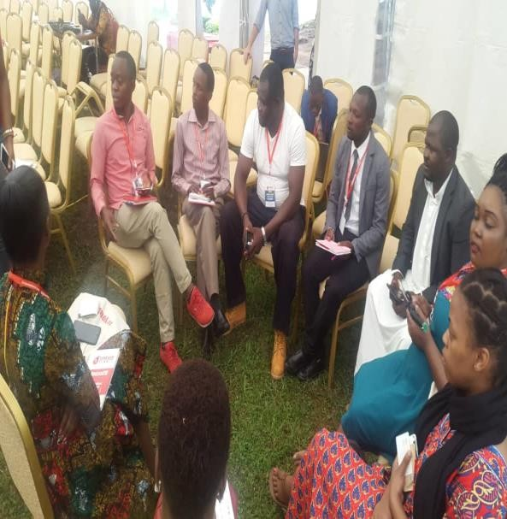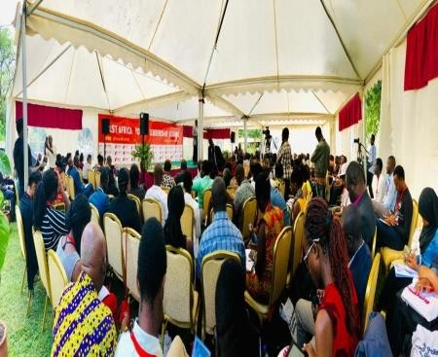
Young Leaders ofEast African (VOYOTA member inclusively ) discussing on the Youlead activity 19TH -23RD NOVEMBER 2018 at MS TCDC. mstcdc@mstcdc.or.tz
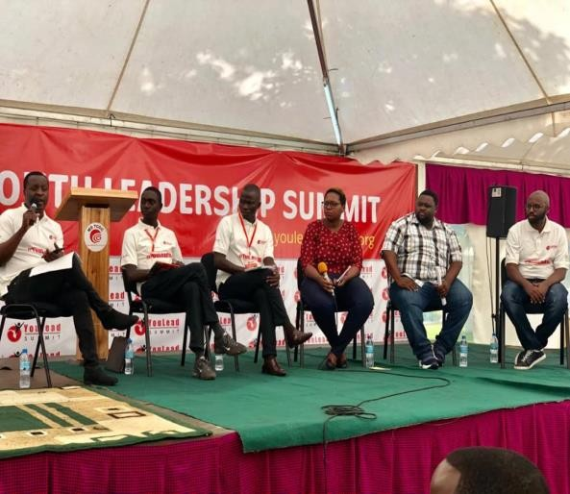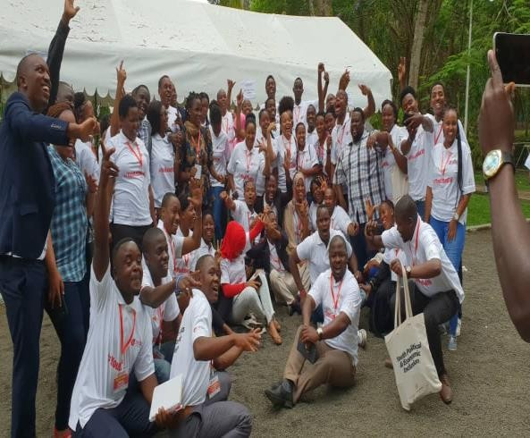
Abdilah Lugome (2nd from right) At a panel discussion hosting on behalf of VOYOTA and a group photo at Youlead on 23rd November 2018 at MC TCDC Arusha Tanzania.

TANZANIA NATIONAL YOUTH SYMPOSIUM INTRODUCTION:
VOYOTA have been full participated on from the preparation to the end of the Tanzania National Youth Symposium of 3rd November, 2018 at East African Community Center - Arusha was specifically intending to enable young people from all over the country to get the clear awareness about politics and economic inclusion in the National base. As noted, that youth are the potential assets in the succession of political and economic prospects. At this activity several organization were full engaged and participation including MS TCDC, YMCA and East African Community Center and VOYOTA inclusively. Among other things the specific activity objective was inclusion of youth in both political, social and economic participation for the sustainable development in Reginal intergration. awareness to youths in political, mental, economical and social liberation to different parts of the Nation concerning their inclusion in Political and Economic Regional integration were trained and full discussed.

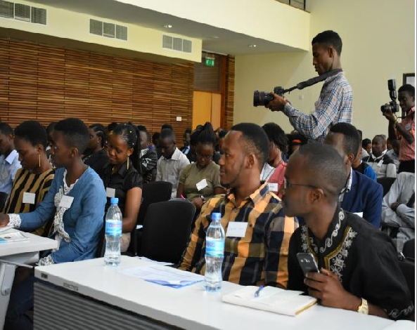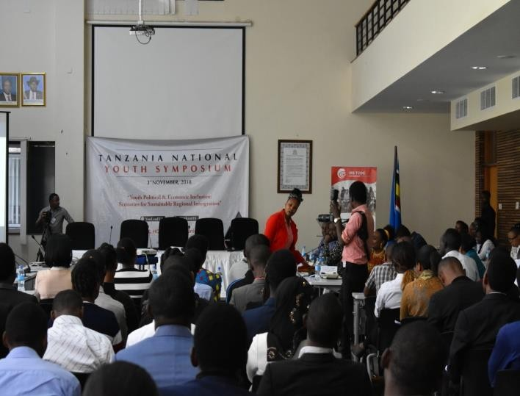

3rd November 2018 people participating at Tanzania national symposium activity
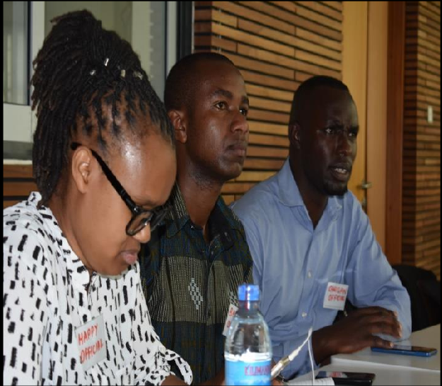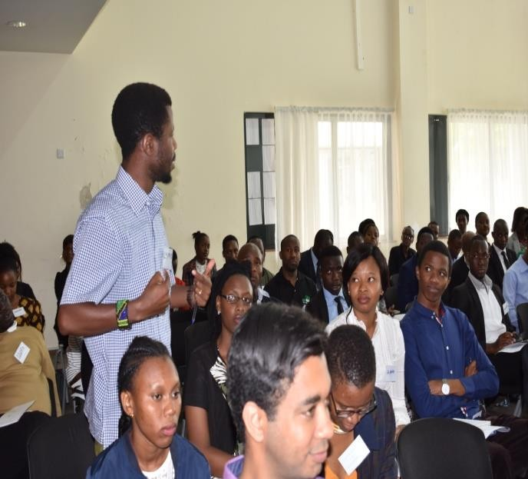

4.0 VOYOTA MEDIA ENGAGEMENT.

Voice of youth Tanzania (VOYOTA) has had a very strong media engagement in the last one month. This engagement has happened at four different platforms namely social media, radio, television and newspaper.
Through our rapid social media platforms on Facebook (voice of youth Tanzania), twitter (@voyota255), instagram (@voyota Tanzania) and you tube (@voyota-Tanzania), we have had a rapid alternative media campaign on awareness creation and empow erment through active sharing and interfaces.

Our National consultative forum on #GBV #SRHR and #HIV/AIDS was comprehensively covered by Mtanzania Daima Newspaper copy of Friday the 19th of October 2018.
VOYOTA through its CEO Mr.Vincent Uhega participated in one TV talk show on Mlimani TV as a panelist where opportunities for young people were discussed, the impediments they face and actions they could take to take advantage of such existing opportunities to fight poverty within their households.
VOYOTA has participated in two live radio talk shows on radio Sunrise in Arusha and radio five in Arusha where we were represented by our founder and CEO (Mr. Vincent Uhega) and (Mr.Musa Paul) our project coordinator respectively. The shows aimed at discussing the role of non-governmental organizations and the youth in development and gender based violence, sexual reproductive health and rights and HIV/AIDS among girls in schools under HERVOICEFUND project.
On Sunday 30th September 2018 at Arusha Region we had a live session with Radio 5 at 12:00 to 12:30pm, we had a discussion on Gender Based Violence in schools, specifically discussing the role of stakeholders in addressing this problem.VOYOTA was represented by the Executive Director and Coordinator of VOYOTA Vincent Uhega and program coordinator Musa Paul respective
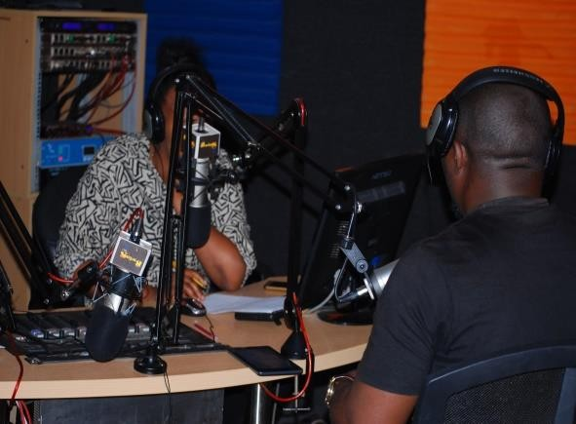

VOYOTA Executive Director and The Coordinator presenting GBV issue at Radio5

ABC TV: The last two forums held at Arusha Municipal and Arusha District on 29th/30th September/2018were covered ABC TV which documented the event of Consultative Forum on Gender Based Violence in schools which were held at Vision for Youth and SOS Village Main office

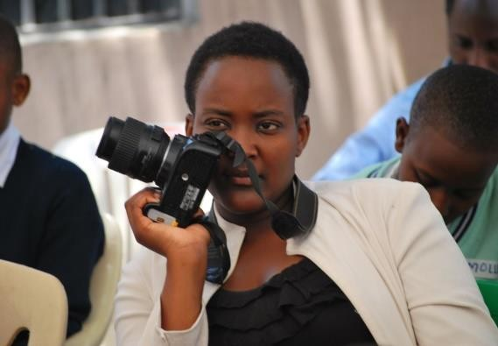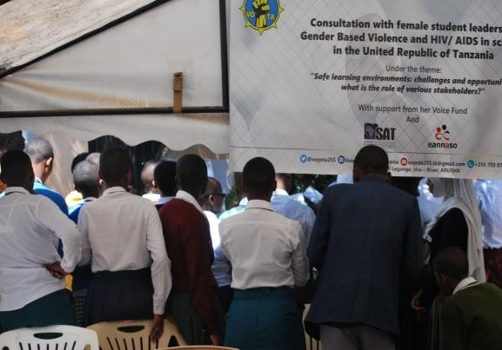

On 18th October 2018at Dar s Salaam during the National Consultative Forum on GBV, SRHR and HIV/AIDS the event was comprehensively covered by ITV, Mlimani TV and Tanzania Daima-News Paper. Where Tanzania Daima News Paper published the event on page two of the newspaper of 19th of October 2018 and Mlimani TV posted the event during the night breaking news of 08:00pm.
On 18th October 2018 early in the morning VOYOTA was represented by CEO Vincent Uhega on live discussion on youth opportunities available in every sector, impediments they face in utilising such opportunities and interventions ought to be done to enable young people to access and effectively utilise such opportunities in the struggle to end poverty within their households and
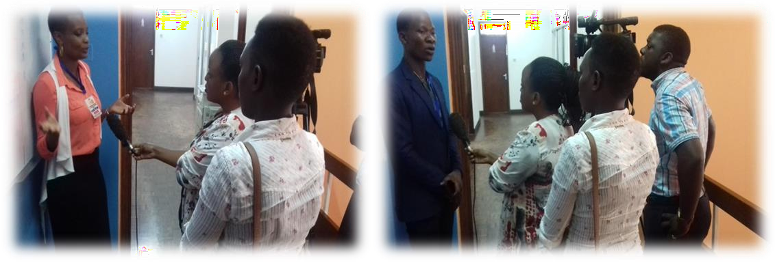

Glory Shio VOYOTA Project officer and Musa Paul (Coordinator) speaking before media on SAUTI YA BINTI Project. 19th October 2018 during the National Consultation Forum prepared by VOYOTA at UNFPA venue Dar es salaam.

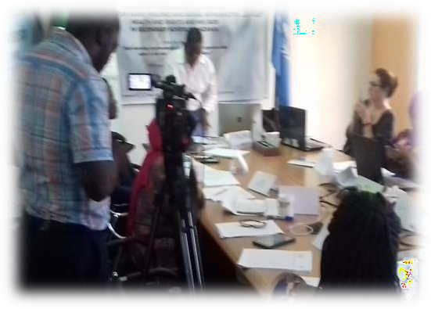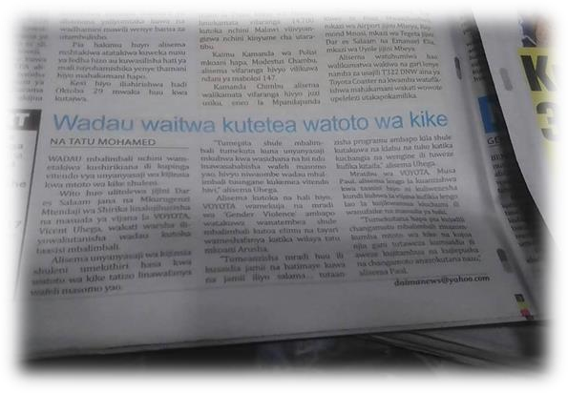
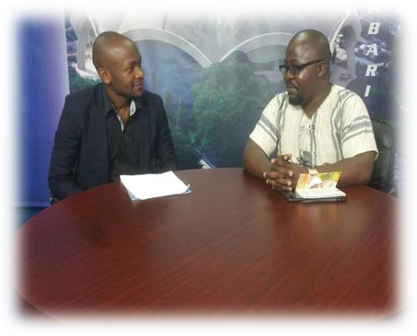

OTHER ENGAGEMENT, WORKSHOP AND ACTIVITIES.
  - PROPOSAL AND BUSNESS PLAN WRITING WORKSHOP.
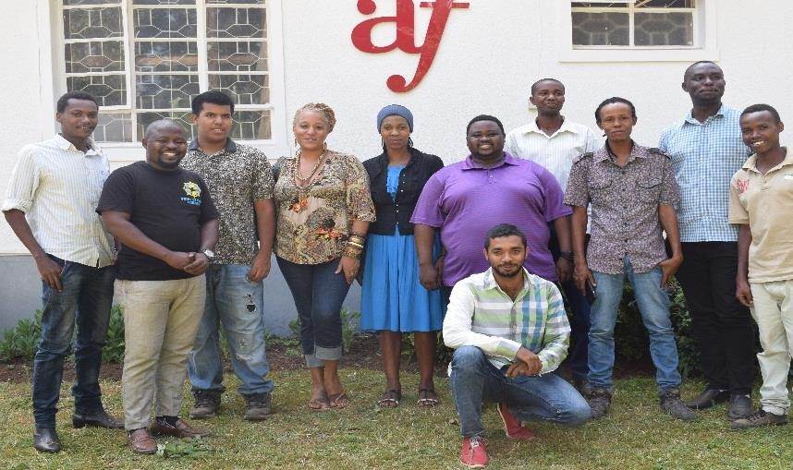
This training that commenced and prepared by VOYOTA to training people in how to write project proposal and business plan that will helps people in their activities to develop and to prepare well subject to their business. At this workshop of two days from 20th to 21st February 2018 and More than 20 people attended the training
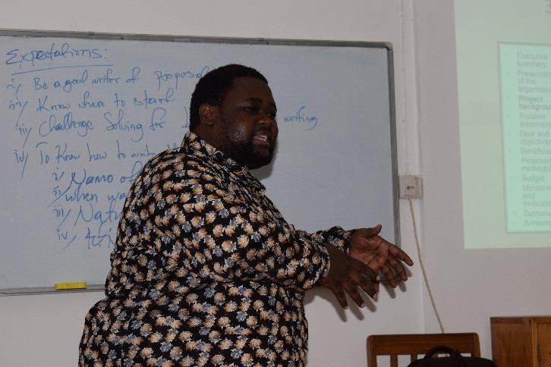
Photo in class and and after workshop

  - CAPACITY BUILDINGS AND DEVELOPMENT TRAINING.
This training only official based training that targeted to train VOYOTA members and leaders to have enough knowledge, whereby more than 4 times we are used to meet for training.
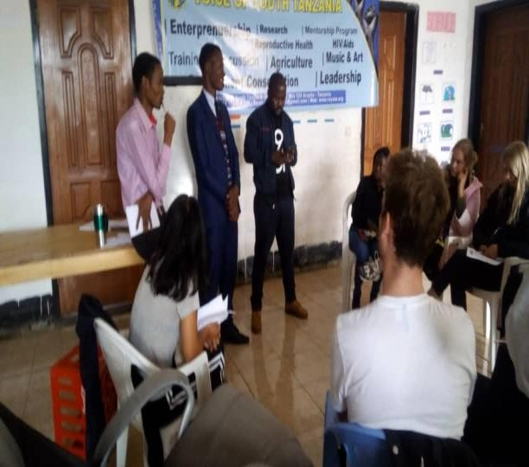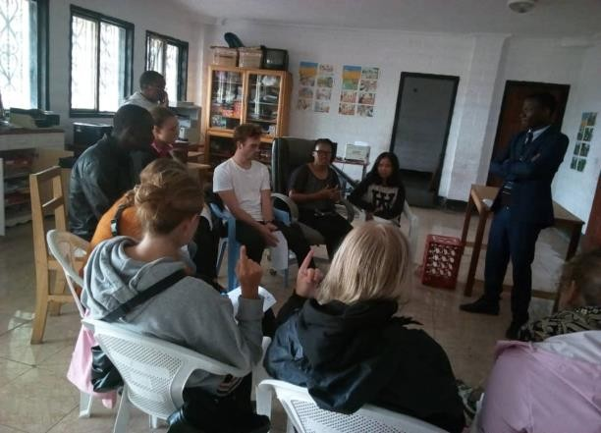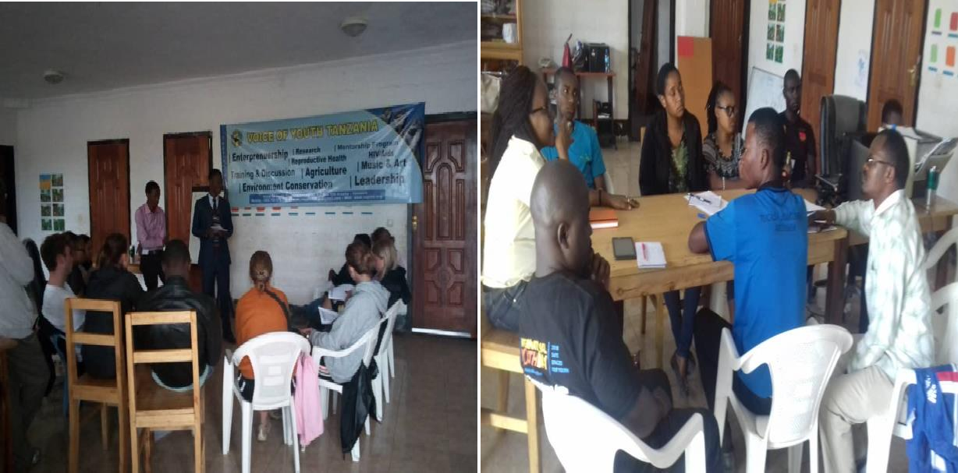
VOYOTA team during the capacity vuilding based on organizational development

6.0 Challenges

Transportation:
It has been difficult to reach out youth in semi – urban and rural area due t o lack of office vehicles. Voice of Youth Tanzania mostly uses public transport in its activities.

Balancing Quality and Growth:
VOYOTA is a fast growing organization and currently grabs every opportunity when presented. This has been difficult for VOYOTA to balance between quality of work and at the same time the need for growth. No permanent office settlement:
For sustainability of any organization it is important for an office to secure permanent location. For instance, between 2015 and 2018 VOYOTA has had three different offices which has cause a lot of

challenges including; lose morally to beneficiaries, partners, supports, volunteers and followers are confused when we move due to expansion, land lords demands and regulations, and this increase operational cost.

Short term funding base:
VOYOTA has no source of income rather than volunteers and short term funding which cause failure to properly plan for its activities due to Lack of long term funding base. Most of the implementation used to fails also due to lack of fund.

