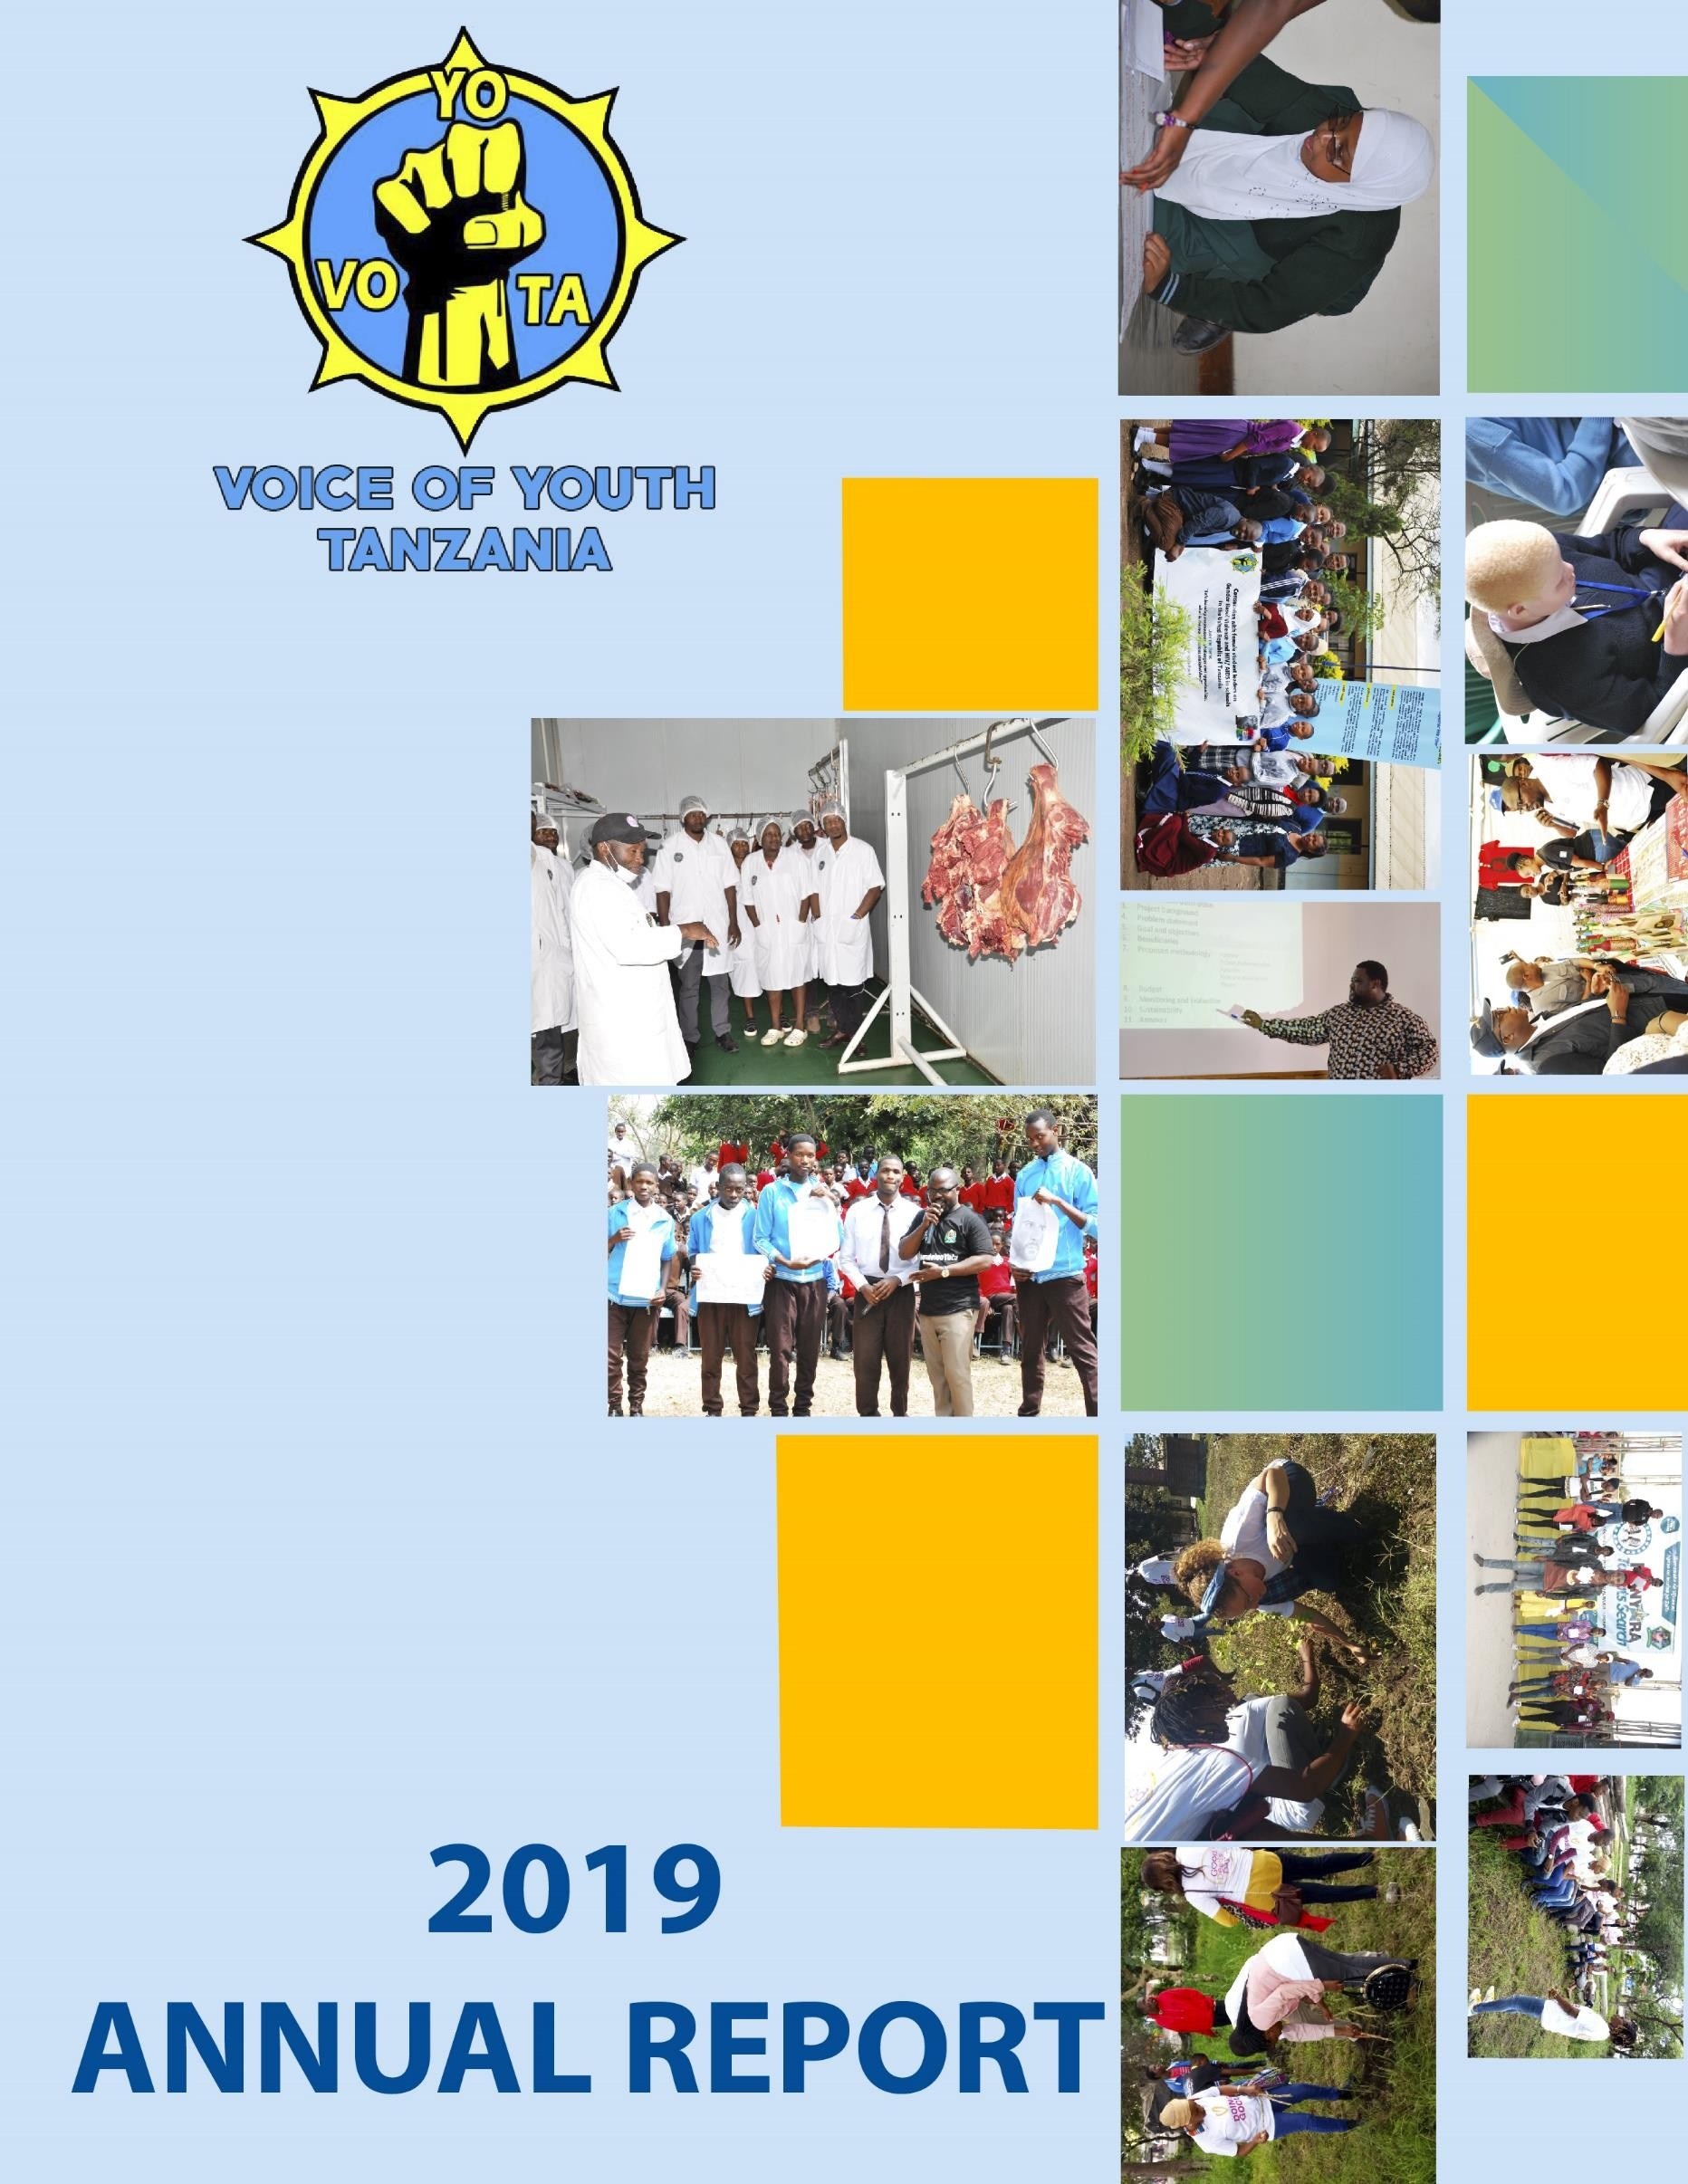

Table of Contents

Table of Contents ii
List of Figures iii
Excecutive summary iv
List of Acronyms v
  - Introduction 1
  - Who is VOYOTA? 1
  - Our Vision and Mission 1
  - Our approach 1
  - Thematic working areas 1
1.6. VOYOTA Partners 2
1.7 VOYOTA Programs and Events in 2019 2
  - Implementation per thematic Areas 4
  - Youth Development and Economic Empowerment 4
    - E-summit on climate resilient agribusiness development for youth 4
    - The international youth day commemoration 4
  - Environment Preservation (Planting Trees, and Awareness Campaigns) 5
    - Good deeds day 5
    - Pathernium hysterophorus (gugu karoti) day 5
    - World Cleanliness Day 6
    - Capacity Building to Youth interview winning and CV writing 7
    - Social media and advocacy training for volunteers 7
  - Youth Health Education Based on Sexual Reproductive Health 7
    - Her voice “Sauti ya Binti” Project 7
    - Secondary school graduation and Provision of Certificates to club leaders 8
    - International Volunteer Day 9
  - Civic Engagement 10
    - Young leadership East African Summit (You Lead) 10
...................................................................................................................................................... 11
    - Participation in the East Africa Legislative Assembly (EALA) 11
  - Other activities implemented by VOYOTA in 2019 13
  - Youth engagement in Agriculture 13
  - Promoting Inclusive Youth Engagement Animal Resources Sector 13
  - Carrier development to the staff 14
    - Media engagement training 14
    - Training on Policy Advocacy and Accountability basing on SRHR 15
  - Challenges and what to be done 15
  - Insufficient funds to run organization activities 15
  - Development partners take time to respond 15
  - Youth have no time to wait 15
  - Conclusion and way forward 16
  - Conclusion 16
  - Recommendations 16

List of Figures
Figure 1 Cleaning activities taking place on the cleanliness day 7
Figure 2 Certificates giving to UNAMBWE Secondary school club leaders 8
Figure 3 Some of the youth who volunteered on the international volunteer day 9
Figure 4 :One of VOYOTA volunteer in the preparation of YouLead summit at MS-TCDC 11
Figure 5 :EALA taking place at EAC. 12

Excecutive summary
This is the second Annual report by VOYOTA after officially registered in2017.It is a short but includes all the whata Voice of Youth Tanzania implemented various in 2019. Some were implemented directly by the program team and others were implemented in collaboration with other players. In this annual report the summary of each initiative is presented showing the results and challenges encountered during implementation. For clarity the results are presented per thematic areas.
The main objective of this report is for sharing with its partners so that we can get views on the point of improvements in the next year. It is also for sharing experiences in the area of youth empowerment in different areas. VOYOTA approach involves working with various partners, through volunteers, communication for change, capacity building and development, empowerment, creating linkages and networks, programs such as financial literacy, youth development, and job training, as well as linking them with opportunities and solidarity with our primary targets who are the youth.
For this year the initiatives implemented includes “sauti ya binti” Her Voice which involved education provision to school girls, Participation in civic engagement summits eg ,You lead and EALA, Youth empowerment economically eg Participation in the E-Summit on the climate resilience and Opportunities identification for youth in climate change, and last but not least is Environmental conservation where various activities were done including; tree planting, environmental cleanliness, campaigns and advocacy.
Also for effectiveness of implantation of the organization programs in future there were also opportunities for carrier development among the team members in media and communication, Accountability and SRH.
The challenges encountered in this year includes high turn-over of volunteers, lack of enough funds and delaying in the implementation of some agreements by other partners.

Vincent Uhega Executive Director,
Voice of Youth Tanzania – VOYOTA.

List of Acronyms
EA | East Africa
EAC | East African Community
EALA | East African Legislative Assembly.
JUWAME | Jukwaa La Wakulima Meru.
NACONGO | National Council for Non-Government organization.
NGO | Non-government organization.
TAHA | Tanzania Horticultural association.
SRHR | Sexual Reproductive Health Rights
TARI | Tanzania agricultural research institute
TICD | Tengeru institute of community Development.
TIN | Taxpayer identification Number
TPRI | Tropical pestsides research institute
V4Y | Vision for Youth.
VOYOTA | Voice Of Youth Tanzan

Introduction

Who is VOYOTA?
Voice of Youth Tanzania (VOYOTA) is a non-governmental organization founded locally in Arusha, Tanzania in 2015 (registered in 2017 - Reg. No 00NGO/00005463 under the Nongovernment Organizations Act, 2002. VOYOTA Tanzania has TIN number 134-382-384, with effect from 21.8. 2017. VOYOTA envisioned to empower young people aged 15-35 to change their lives for sustainable development. We believe in working together to achieve and sustain our impact.

Our Vision and Mission
Our Vision is to make Tanzania a society with unlimited possibilities and transformative opportunities for youth.
Our Mission is To support Youth efforts by promoting social welfare through research, vocational trainings, economic empowerment, awareness raising, networking and advocacy.

Our approach:
Our approach involves working with various partners, through volunteers, communication for change, capacity building and development, empowerment, creating linkages and networks, programs such as financial literacy, youth development, and job training, as well as linking them with opportunities and solidarity with our primary targets who are the youth.
  - Thematic working areas
VOYOTA has a wide range of activities of which the priority areas are as follows:
- Youth Development and Economic Empowerment(Training and capacity building n on Entrepreneurship and Business, Business Plan Writing skills and Youth groups forming
)
- Environment Preservation(Planting Trees, and Awareness Campaigns )
- Youth Health Education Based on Sexual Reproductive Health and Life Skills for unlocking youth mindset
- Civic Engagement (Civic education, Leadership Trainings, Dialogues, Accountability and advocacy awareness.
  - Membership:
VOYOTA is a member of Arusha Youth Development Stakeholders Forum, National Council of NGOS – NACONGO, Arusha Young Directors Forum.

1.6. VOYOTA Partners.
Voice of Youth Tanzania is non-government organization, nonpartisan but this fact does not mean has not participating with these organizations. VOYOTA is full and partial participating with both Government and other non-government organization which includes Vision for Youth, WANENE Entertainment, MWOSE -TANZANIA, Her-Voice fund, JUWAME both horizontal and vertical.

1.7 VOYOTA Programs and Events in 2019
Some of the projects which have been implemented by VOYOTA include

Her Voice “ Sauti ya Binti Project”

Sauti ya Binti Project is the project that aimed at putting female student leaders at the forefront of fighting against gender based violence, creating opportunities and platforms where they can air their views and also enhance their leadership capacities so as to create a safe learning environment for all and prepare them for life after schools.

Good deeds day

On 16th April 2019 the Voice Of Youth Tanzania (VOYOTA) with other partners Vision For Youth, ECHO East Africa, SOS-Village Arusha, Job opportunity College, A town TV, Radio Five, Government officers, Little Arusha creation and Kambele Investment implemented a back to green activity by Planning 150 trees at Leganga and clearing the environment at USA River.

Young Leadership East African Summit (You Lead)

You Lead is a unique opportunity for youth leaders to gather for training and facilitating cross country youth networking to accelerate the EAC regional integration aspirations. As the name suggests You Lead is derived from the word Youth leadership it’s all about young leaders coming together to learn and explore ways to help grow, support and participate in youth leadership and mission. We as Voice of Youth Tanzania (VOYOTA) got a chance to fully participate in the summit as volunteering and partners.

Pathernium hysterophorus (gugu karoti) day

Is a special event organized to create awareness to the community on the existence of the invasive species for stance pathenaeum hysterophorus (gugu karoti) by giving out the education on how to control and eliminate the invasive plants due to its effects in agriculture, humans and tourism.

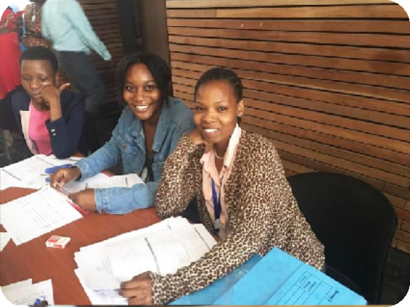International Women’s Day
3

The International Women’s Day is held annually on March 8 to celebrate women’s achievements throughout history and across nations. It is also known as the United Nations (UN) Day for Women’s Rights and International Peace. The UN drew global attention to women's concerns in 1975 by calling for an International Women's Year. This year at regional level it was done in Arusha where VOYOTA members participated through sharing experience and learning from others.

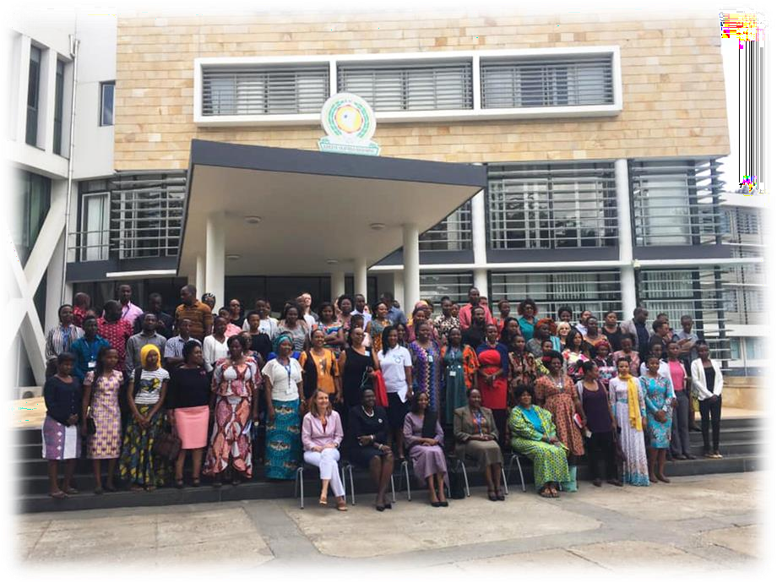

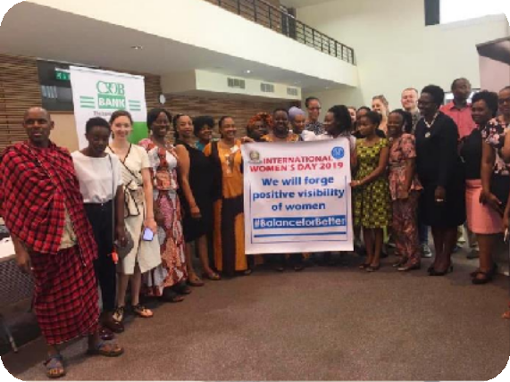

| P a g e

Implementation per thematic Areas

Youth Development and Economic Empowerment
In the area of youth development and economic empowerment various activities were done including the following.

E-summit on climate resilient agribusiness development for youth
In November 2019 VOYOTA team participated in the e-summit event held at Arusha, Tanzania with the connection to other East African countries hosted by Agri-Profocus Tanzania organization and SNV Netherlands development Organization. The aim was to
      - Provide a learning and knowledge sharing platform for young agri-entrepreneurs, allowing them to tap into the available climate smart investment opportunities in order to build climate resilient agribusinesses.
      - Provide a platform for young agri-preneurs to learn about climate change adaptation and mitigation strategies hence explore opportunities to innovate investable climate resilient interventions.
      - Create awareness about climate change adaptation and mitigation strategies in agribusiness;
      - Explore innovative and scalable agro-ecological business models that are bankable;
      - Increase collaboration and learning between stakeholders and agri- entrepreneurs

Achievements:

In This meeting 10 youth identified by VOYOTA attended. The knowledge gained in this event is expected to enable youth develop and implement projects and programs which will improve their economic status. This event opened up the awareness of the youth on the possibilities to engage in Agriculture and succeed taking account the climate smart practices shared.

The international youth day commemoration.
As an opportunity for youth development and economic empowerment in 2019, VOYOTA participated in the international youth day conducted at Arusha General Tire Ground where the guest of honor was Honorable Representing the District Administrative secretary.
International Youth Day 2019 examines how Government young people and youth-led and young-focused organizations, as well as other stakeholders, are transforming education and how these efforts are contributing to the achievement of 2030 Agenda for sustainable development.

The insist in this event was awareness creation on

      - Issues affecting young people (Health, Economical and Technologies)
      - Needs of education to young people and
      - Industrial Revolution “Tanzania ya Viwanda”

Achievements:

VOYOTA got a chance to meet other youths where they shared experience and exhibited what they are doing in youth empowerment.

Environment Preservation (Planting Trees, and Awareness Campaigns)
In the thematic area ii where youth are expected to take lead in the environmental conservation, various activities have been implemented as listed and explained bellow:

Good deeds day
On 16th April 2019 the Voice Of Youth Tanzania (VOYOTA) with other partners Vision For Youth, ECHO East Africa, SOS-Village Arusha, Job opportunity College, A town TV, Radio Five, Government officers, Little Arusha creation and Kambele Investment implemented a back to green activity by Planning 150 trees at Leganga and clearing the environment at USA River.

Pathernium hysterophorus (gugu karoti) day

Is a special event organized to create awareness to the community on the existence of
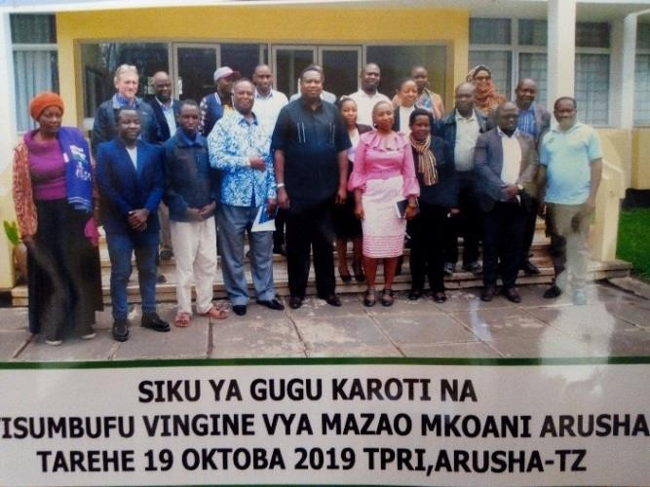
the invasive species for stance Athenaeum hysterophorus (gugu karoti) by giving out the education on how to control and eliminate the invasive plants due to its effects in agriculture, humans and tourism.
This event was conducted on 19th October 2019 the at Tropical Pesticides Research Institute (TPRI) hall and the Host of the event was TPRI with the
collaboration of other stakeholders such as ECHO, TARI selian, TARI Tengeru, VOYOTA, TANAPA , HORTCULTURE and TAHA.
The Voice Of Youth Tanzania (VOYOTA) Participated as a Youth representatives in Arusha region and collaborated in committee meetings, creating of posters for the invitations, giving instructions the guests attended in the summit day.

Plan of the activity:

To create awareness to the community on the existence of the invasive species for stance pathenium hysterophorus (gugu karoti) by giving out the education on how to control and eliminate the invasive plants due to its effects in agriculture, humans and tourism.

Achievement:

- The provision of education and awareness to the farmers to different districts in Arusha Region especially In Arumeru district.
- Provision of education on invasive species to 300 people on the day of Gugu karoti.
- People were given the chance to show and sell their products as Agricultural exhibition in the conference day as a part of agribusiness and entrepreneurship to support the farmers.

World Cleanliness Day.
World Cleanliness Day is promoted by the United Nation and for 2019 China being the host country. This Day is also known as the Environment Day, Eco Day which is celebrated to spread awareness about the Environment and its effects on the daily life of the people.
In this year it was don done on 6th June 2019; where VOYOTA participated by volunteering in cleaning environment and awareness creation on environment conservation in Arusha municipality. This was done in collaboration with other organization such as Nipe fagio and Vision for Youth.
Objectives behind celebrating World Environment Day

The objectives for the world environment day this year were

      - To spread awareness among common people about the issues of the environment.
      - To encourage common people from different society and communities to actively participate in the celebration as well as become an active agent in developing environmental safety measures.
      - To encourage people to make their nearby surroundings safe and clean to enjoy safer, cleaner and more prosperous future.

World Cleanliness Day 2019: Theme

The theme for the World Environment Day 2019 is "Air Pollution". Air pollution is increasing day by day and it seems complex to control it but nothing is impossible we should come together to combat it. And for this it is necessary to understand different types of pollution, how it affects our health and environment will help us to take steps towards improving the air around us. We can't stop breathing but we can do something to improve the quality of air that we breathe.
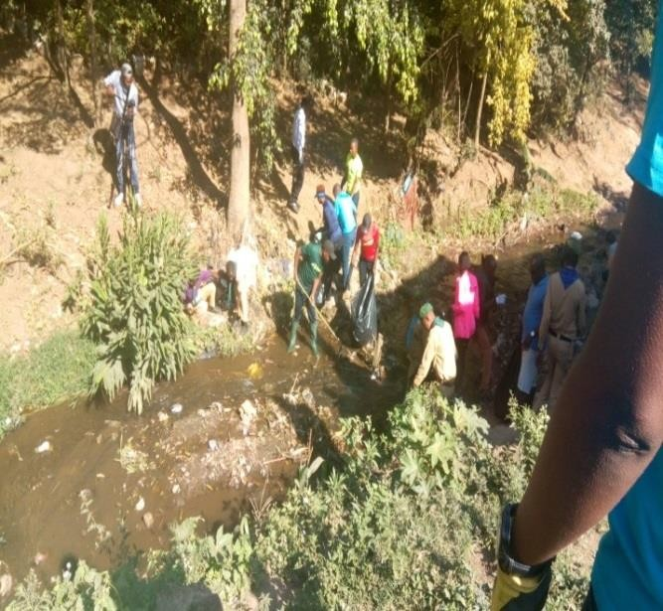
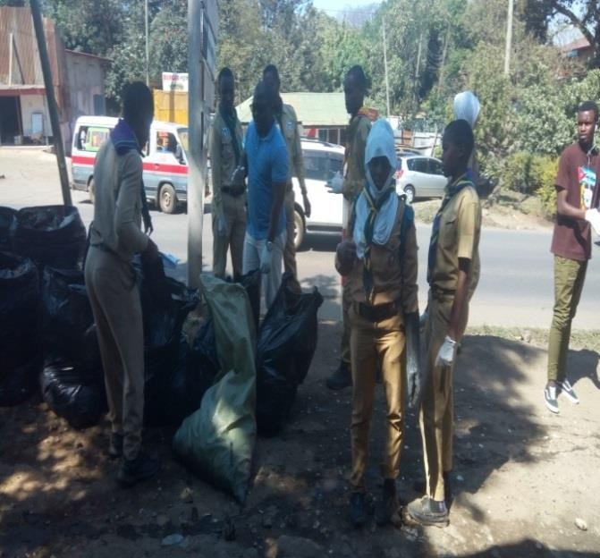
Figure 1 Cleaning activities taking place on the cleanliness day

Capacity Building to Youth interview winning and CV writing
VOYOTA conducted training to 100 youths on the CV writing skills and how to win interviews; this training was conducted in June 2019 by the VOYOTA facilitator with the objective of improving their skills.

Social media and advocacy training for volunteers
VOYOTA conducted a special training to volunteers in June this year on how to use socio media and advocacy. The aim was to help youth use socio media in a positive ways and engage in the lobbying and advocacy for their rights and the rights of their fellow.

Youth Health Education Based on Sexual Reproductive Health
Under this thematic area most of activities done were directed to school girls especially under the Sauti ya Binti project, it was also implemented in line with other activities.

Her voice “Sauti ya Binti” Project
Sauti ya Binti Project is the project that aims at putting female student leaders at the forefront of fighting against gender based violence, creating opportunities and platforms where they can air their views and also enhance their leadership capacities so as to create a safe learning environment for all and prepare them for life after schools.

Planed activities:

      - In 2019 the plan was to give the certificates to the form four girls who benefited from the project of sauti ya binti who have been the members and leaders of Sauti ya binti club in their school.

Achievements:

In the year of 2019 the her voice “sauti ya binti” project succeeded to open and run active clubs in the total of seven secondary schools in Arumeru district Arusha, the schools which sauti ya binti clubs project runs are Unambwe secondary, Godwill secondary school, Poli secondary school, Sing’isi secondary school, Uraki secondary school, Ngongongare secondary school and Kilimani secondary school.

Challenges:

The big challenge is financial stability; the funded capital is limiting the harmonization of the project.
Lesson learnt:

Young girls in Arusha region facing problems in human rights violent which caused by poor cultural believes, economic hardship, and they have no place to report.
Way forward:

      - VOYOTA will continue conduct Capacity Building programs to Adolescent in schools and out of school teenagers.

Secondary school graduation and Provision of Certificates to club leaders
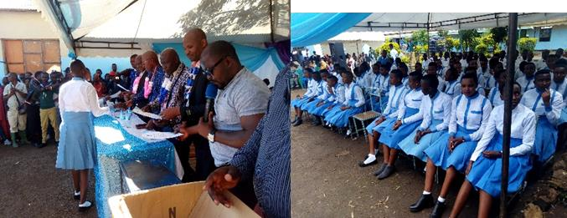
Also VOYOTA succeeded to provide the membership and leadership certificate to the form four girl’s students on their graduation at Unambwe secondary school in the day of 19.10.2019.

Figure 2 Certificates giving to UNAMBWE Secondary school club leaders

International Volunteer Day
International Volunteer Day (IVD) is an opportunity for us all to promote volunteerism, encourage governments to support volunteer efforts and recognize volunteer contributions to the achievement of the Sustainable Development Goals (SDGs) at local, national and international levels.
At United Nation Volunteer, they marked International Volunteer Day 2019 with the theme "Volunteer for an inclusive future", highlighting SDG 10 and the pursuit of equality including inclusion through volunteerism.
Volunteering provides opportunities for people, particularly those often excluded, to concretely impact their own lives and play a constructive role in their communities by volunteering their time and skills. Through volunteerism, communities around the world often experience strengthened solidarity and inclusion.
This year the international volunteer day was conducted on 5th December 2019, at DSW offices in from different institutes participated. As local organizers Voice of Youth Tanzania played role in the following ways:-
- Coordinating and provision of resources support such as 20 youths

- Entertainment, where by one Member from VOYOTA presented Poem to the attendants.
- Organizing and invite other members to participate.

- Provision of education of Sex Health reproductive to the Youths.

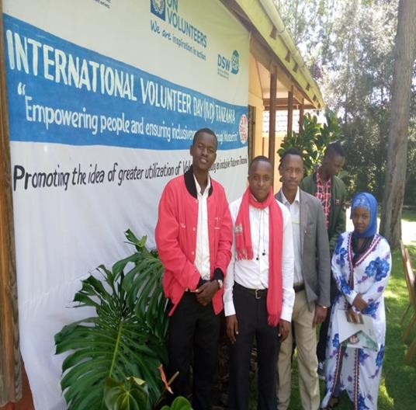
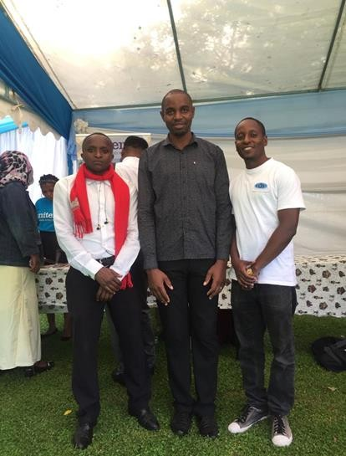
Figure 3 Some of the youth who volunteered on the international volunteer day

Civic Engagement
In 2019 VOYOTA participated in various dialogues and discussion aiming at gaining and delivering civic education and awareness creation. The team also participated in the organization and running of the youth events like good deeds days, YouLead Summit and East African Legislative Assembly.

Young leadership East African Summit (You Lead)
YouLead is a unique opportunity for youth leaders to gather for training and facilitating cross country youth networking to accelerate the EAC regional integration aspirations. As the name suggests YouLead is derived from the word Youth leadership it’s all about young leaders coming together to learn and explore ways to help grow, support and participate in youth leadership and mission. We as Voice of Youth Tanzania (VOYOTA) got a chance to fully participate in the summit by both volunteering and partnership.
Other partners participated in 2019 YouLead summit are Faraja Foundation, YouLead, IRI, Westminster Foundation For Democracy and Action Aid. And the motto for 2019 YouLead summit is LEAVING NO ONE BEHIND. YouLead summit conducted in 5 days from November 11th 2019 to 15th November 2019 including 2 days for East African Legislative Assembly for youths.

Background information on the activity

YouLead was organised since 2017 by MS-Training Centre for Development Cooperation, the East African Community (EAC) Political Affairs Department and Africa Alliance of YMCAs with the participation of other partners, the East Africa Youth Leadership Summit (YouLead) is East Africa’s biggest youth gathering recognised by the EAC in line with the provisions of the EAC Youth Policy (2016) priority 14 which mandates the EAC Secretariat to build networks and partnerships to, ‘Institute an Annual Youth Leaders’ Forum with the EAC Secretary General as a regional platform for youth engagement with the EAC leadership.
YouLead gives and amplifies youth voices in key regional political processes and strengthens their mandate to participate in leadership at country level. YouLead facilitates cross-country youth networking to accelerate the EAC regional integration aspirations. Participants are mobilized across various sectors: political leaders and policy makers, business, ICT, agriculture and the non- governmental organizations.
In short YouLead aims at

- To increase the quality and number of youth leaders holding political positions across EAC.
- To deepen business cooperation and a partnership among business leaders cross EAC.

- To give youths a voice in key regional political processes of EAC and accelerating regional integration. Subject to these objectives discussed which are:

Challenges:

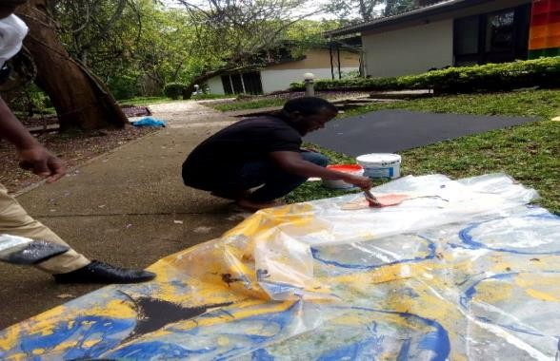
  - No effective National Youth Trends in Political and Economic Inclusion and Youth Participation in EAC Integration Priorities and Processes due to the absence of Youth National council in Tanzania and Burundi.
  - Bureaucracy in getting permit of free movements from one country to another

Figure 4 :One of VOYOTA volunteer in the preparation of YouLead summit at MS-TCDC

Participation in the East Africa Legislative Assembly (EALA)
As part of learning and sharing experience VOYOTA was also represented in the 2nd EALA which took place at the EAC Headquarters in Arusha. Among other the following were the motion discussed during EALA 2019
- Motion for the resolution of the house to urge partners’ states through the respective authorities to ensure the establishment of the National Youth Councils for Tanzania, South Sudan and Burundi and Subsequently the East African Youth Council.
- Motions for a debate on the EAC member states to adopt ACDEG resolutions.
- As we wait for the implementation of one currency, we propose the acceptance of use any EAC currency accepted legal tender in each of respected currency. Such that local business can accept payments in any at the 6 EAC currencies.
- A motion for the resolution of East African Youth Assembly For the harmonization of youth programs, project through EALA with a vision to one common youth voice and youth participation in all sectors.
- Motion for the House to debate the implementation of uniform tuition policies and rejuvenate institutional/ student exchange program across the EAC.
- Motion for a resolution of the House for elimination of EAC work permit requirements in the spirit of enhancing freedom of labor movement.
- Motion for the House to debate the processes of harmonization of regional telecommunication rates in East Africa.
- Motion for a resolution urging governments to prioritize security in the East African Region.

- A motion for a resolution urging east African states to grant young entrepreneurs at least 1-year of tax holiday in order to enable first stabilization and growth of their businesses.
- A motion for a resolution of the assembly for youth representative on the East African legislative assembly so that youth voices can be incorporated in the discussions at East African level.

Achievements:

      - VOYOTA has become partner in EALA from 2019 onwards

      - More than 250 young leaders of EAC have gained and exchanged new ideas and designed new initiatives for EAC integration.
      - Nearly 50% Gender parity achievement among delegates

      - No EAC country left behind all 6 EAC countries represented

      - Successful in helping youth understand their leadership role

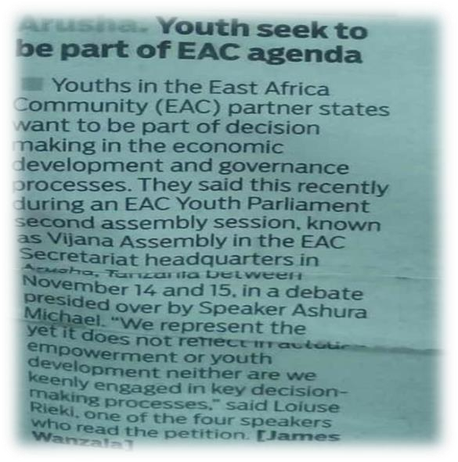
      - 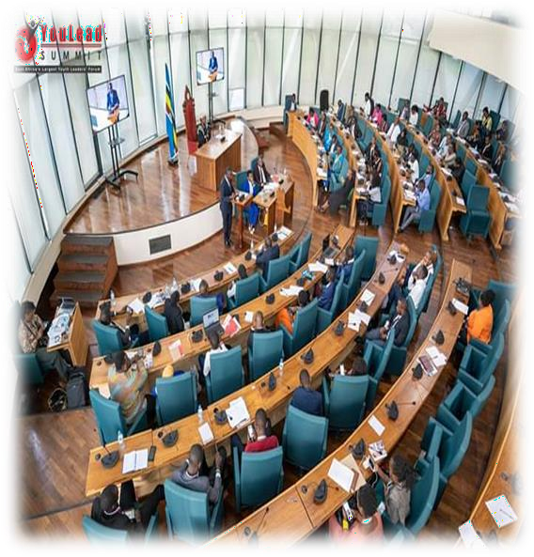.Successful in giving youth leaders and opportunity to meet and connect with fellow young leaders from across the EAC.

Figure 5 :EALA taking place at EAC.

Other activities implemented by VOYOTA in 2019
Together with the above mentioned activities VOYOTA has also worked in other important matters as listed below:

Youth engagement in Agriculture:

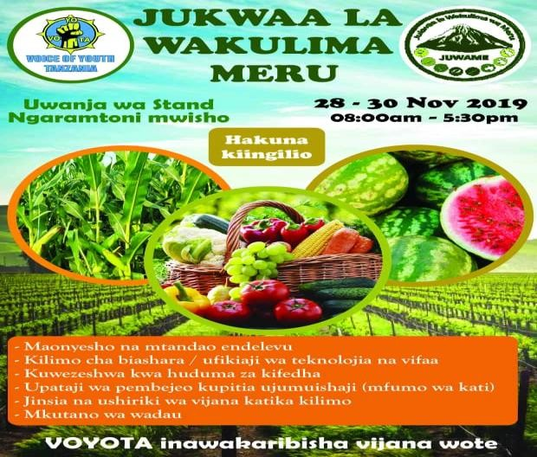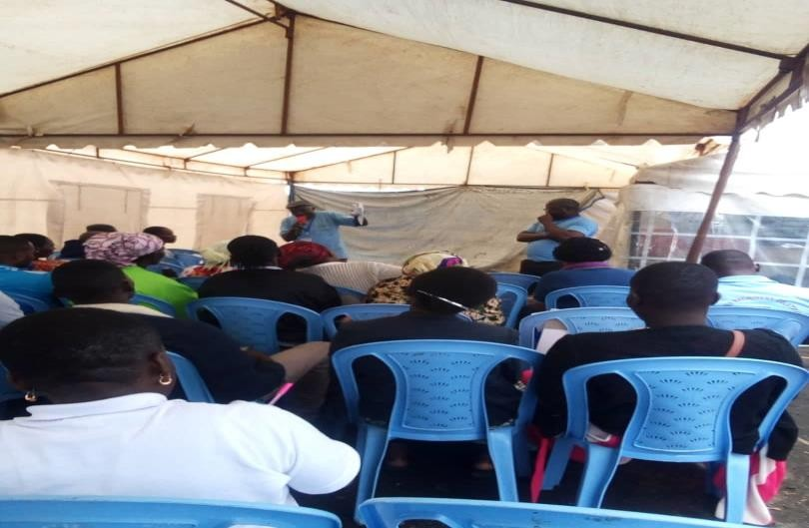In year 2019 in collaboration with JUWAME FARM PARTNERS Voice of Youth Tanzania represented youth in the preparation and Implementation of Meru Farmers Fairs which in this time round took place at Ngaramtoni Jumbo Ground. VOYOTA engaged in designing of posters for youth invitation, designed and printed the certificates and

participated running the event as Masters of ceremony was from VOYOTA.

The seminars and other meetings were run and Moderated by VOYOTA. Also in the areas of event evaluations and report writing was done by youth.
  - Promoting Inclusive Youth Engagement Animal Resources Sector
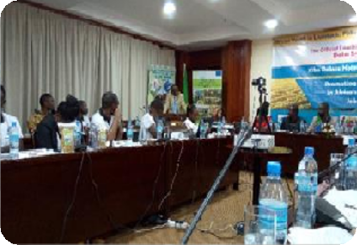
African Youth in Livestock, Fisheries &Aquaculture Incubators Network (AYL_FAIN) is a network which was formed under the support of African Union – Interafrican Bureau for
Animal Resources (AU-IBAR) with the aim of connecting and bringing together African youth who are in Agricultural and Livestock industries.
In 2019 they officially launched a network in Tanzania going with the name of TYL_FAIN-Tanzania under the theme of “Promoting Inclusive Youth Engagement in Africa’s Animal Resources Sector for Job and Wealth Creation”. With the objectives of (1) Connecting and

13 | P a g e

linking Young people to market opportunities (2) Training to young entrepreneurs on quality assurance.
VOYOTA as youth organization participated in the preparation of the event through identification and invitation of youth who shared what they are doing and gained knowledge on how to scale up their projects. The three days event where on the first day there was a field visit, second day it was official launching of the network and on the third day was action planning session.

Achievements

Through participation in this event youth gained knowledge on the in Livestock, Fisheries & Aquaculture. They were able to identify the opportunities in this sector an at last all participated on action plan for the network where members identified activities and partners the network can work with.

Carrier development to the staff
In 2019 members and staff of VOYOTA were fortuned to attend various training to improve their skills in implementing their vision and mission. Some of these trainings include:

Media engagement training
One staff from Voice of Youth Tanzania (VOYOTA) had the opportunity to attend a three day training stared 4th November 2019 to 6th November 2019 on “Engaging the Media” that was organized and conducted by the Aga Khan University-Graduate School of media and communication. The purpose of the three day course was to prepare civil society organizations on how to engage with the media to effectively promote the issues they champion for and raise awareness and mobilize for social change. The training is beneficial and applicable in organization’s day to day interventions we learnt in community.

Training on Policy Advocacy and Accountability basing on SRHR
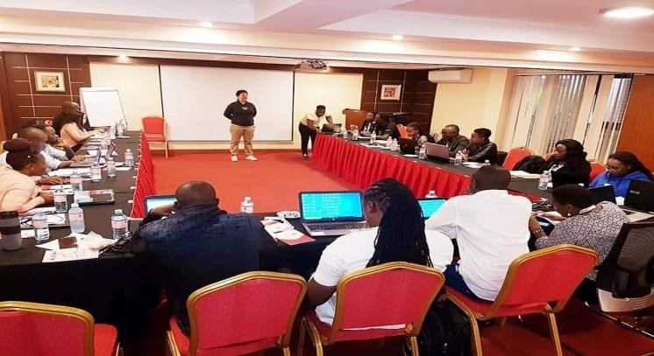30th October-1st November 2019, one VOYOTA staff participated in the training on Policy Advocacy and Sexual Reproductive Health rights which was conducted in Nairobi by
ACOUNTABILITY INTERNATIONAL the aim is
for public servants to improve their delivery of health, share their successes and learn from their failures making for quality, improved, sustainable and human rights based health access for all a reality. All leaders, not just governments, need to act to ensure transparency and dialogue is part of the health and social justice process. The knowledge gained is usefully for the organization and the partners at large.

Challenges and what to be done
Despite all achievements listed and elaborated above VOYOTA has faced various challenges in 2019. These can be divided in three parts (i) Institutional challenges (ii) Stakeholders challenges and (iii) Financially

Insufficient funds to run organization activities
It has been difficult to implement some of the organization activities due to insufficient funds. In 2019 no external funder who funded the programs. So most of the activities were funded by the members and on the volunteering basis.

Development partners take time to respond
In all meetings there are a lot of plans set which need to be implemented but it takes time for those who are given the assignment to respond hence no action taken after the meetings.

Youth have no time to wait
Most of youth who volunteered at the organization were expecting quick return in terms of money, but when they find out that its taking long they quit. This has in one way or another contributed to lack of continuity of some programs/initiatives

Conclusion and way forward

Conclusion
At this end it can be concluded that VOYOTA has touched all its four (4) thematic areas directly on directly. Lack of funds can be a problem but when you have social capital you can still implement the planned activities.

Recommendations
To combat the challenges encountered above the organization is capitalizing on sustainability of the organization through engagement of professionals who are ready to devote their time in shaping the programs and advice on the right tracks to take. It also used these professionals in writing proposals which can attract development partners who will fund the projects in in future.

